223028000_MUSONERA JEAN DE DIEU

A1: Fragment & Recombine Main Fact
- Table expense_A creation on Node A:

CREATE TABLE Expense_A (
Expense_ID INT PRIMARY KEY,
Description VARCHAR(100),
Amount DECIMAL(10,2)
);
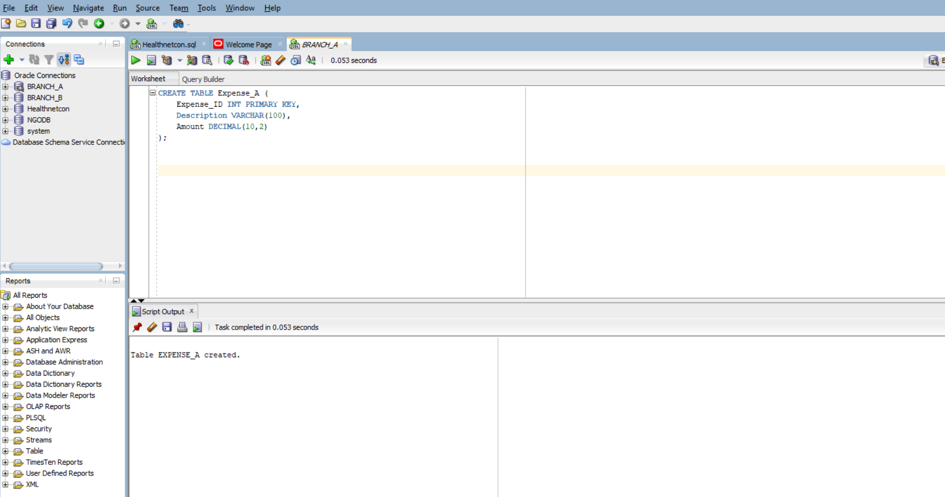

Table expense_B creation on Node B:
CREATE TABLE Expense_B (
Expense_ID INT PRIMARY KEY,
Description VARCHAR(100),
Amount DECIMAL(10,2)
);
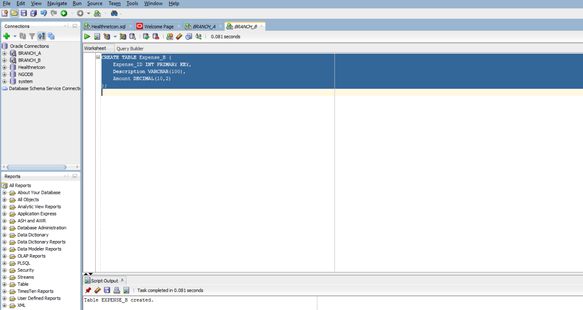
- Inserting data in expense table on node A

INSERT INTO Expense_A VALUES (1, 'Travel', 120.50);
INSERT INTO Expense_A VALUES (2, 'Meals', 45.00);
INSERT INTO Expense_A VALUES (3, 'Supplies', 78.90);
INSERT INTO Expense_A VALUES (4, 'Taxi', 33.25);
INSERT INTO Expense_A VALUES (5, 'Hotel', 200.00);
COMMIT;

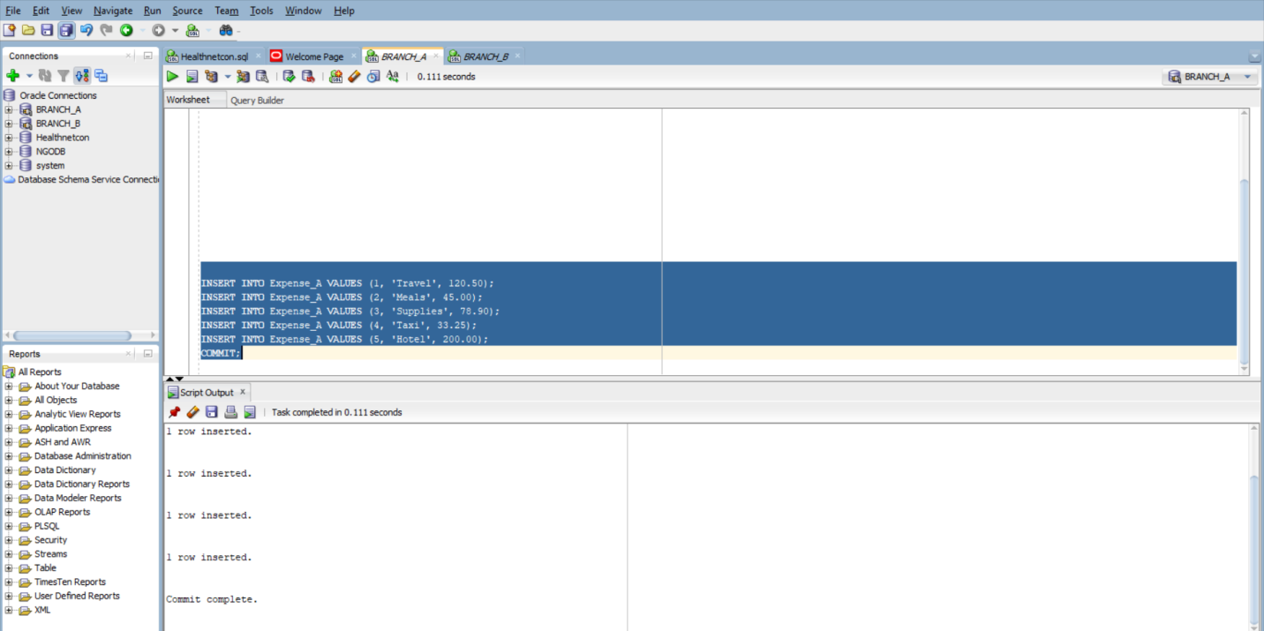
Checking Inserted data
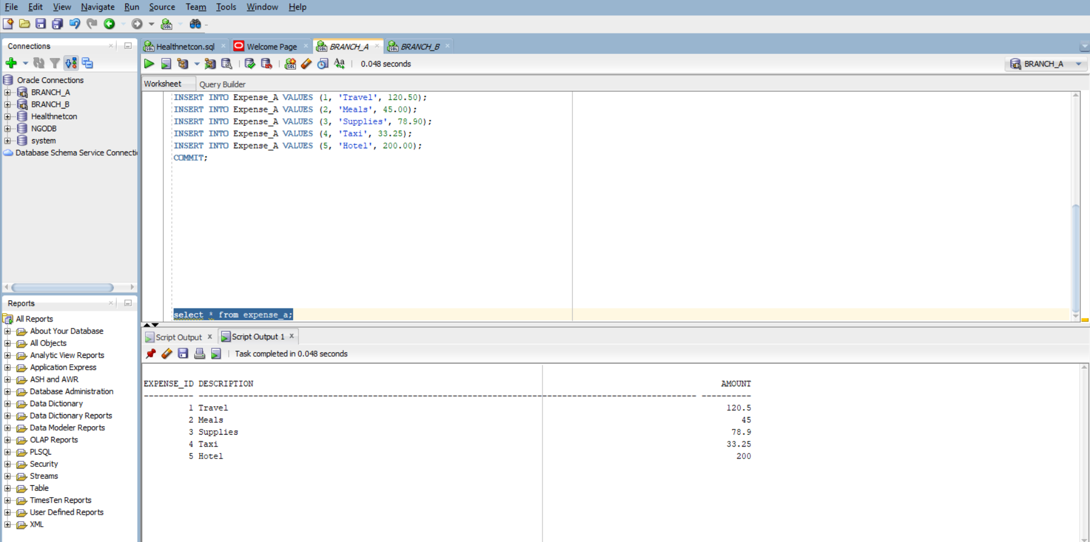
Inserting data in expense table on node B

INSERT INTO Expense_B VALUES (6, 'Conference', 150.00);
INSERT INTO Expense_B VALUES (7, 'Flight', 300.00);
INSERT INTO Expense_B VALUES (8, 'Dinner', 60.00);
INSERT INTO Expense_B VALUES (9, 'Stationery', 25.75);
INSERT INTO Expense_B VALUES (10, 'Snacks', 15.00);
COMMIT;

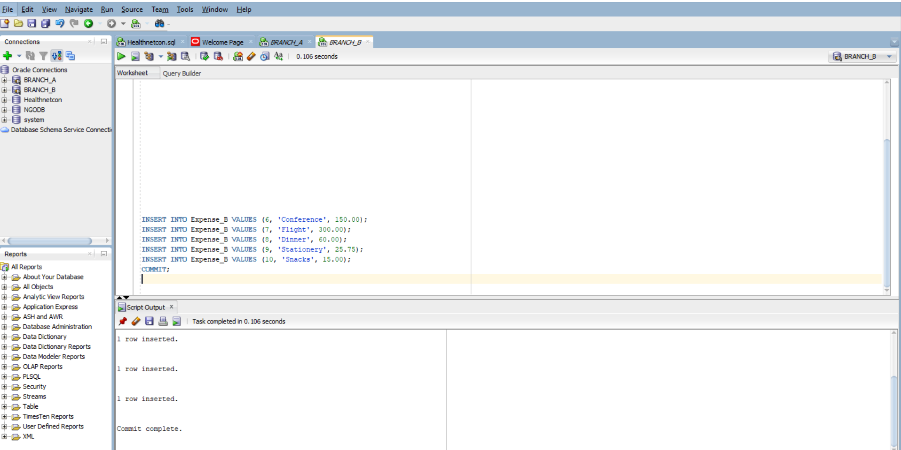

Checking inserted data
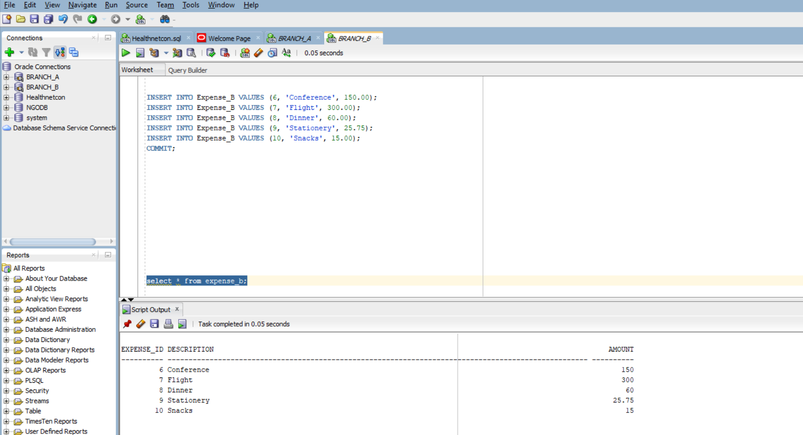

3.Create View on Node_A

CREATE VIEW Expense_ALL AS
SELECT * FROM Expense_A
UNION ALL
SELECT * FROM Expense_B@branch_b_link;
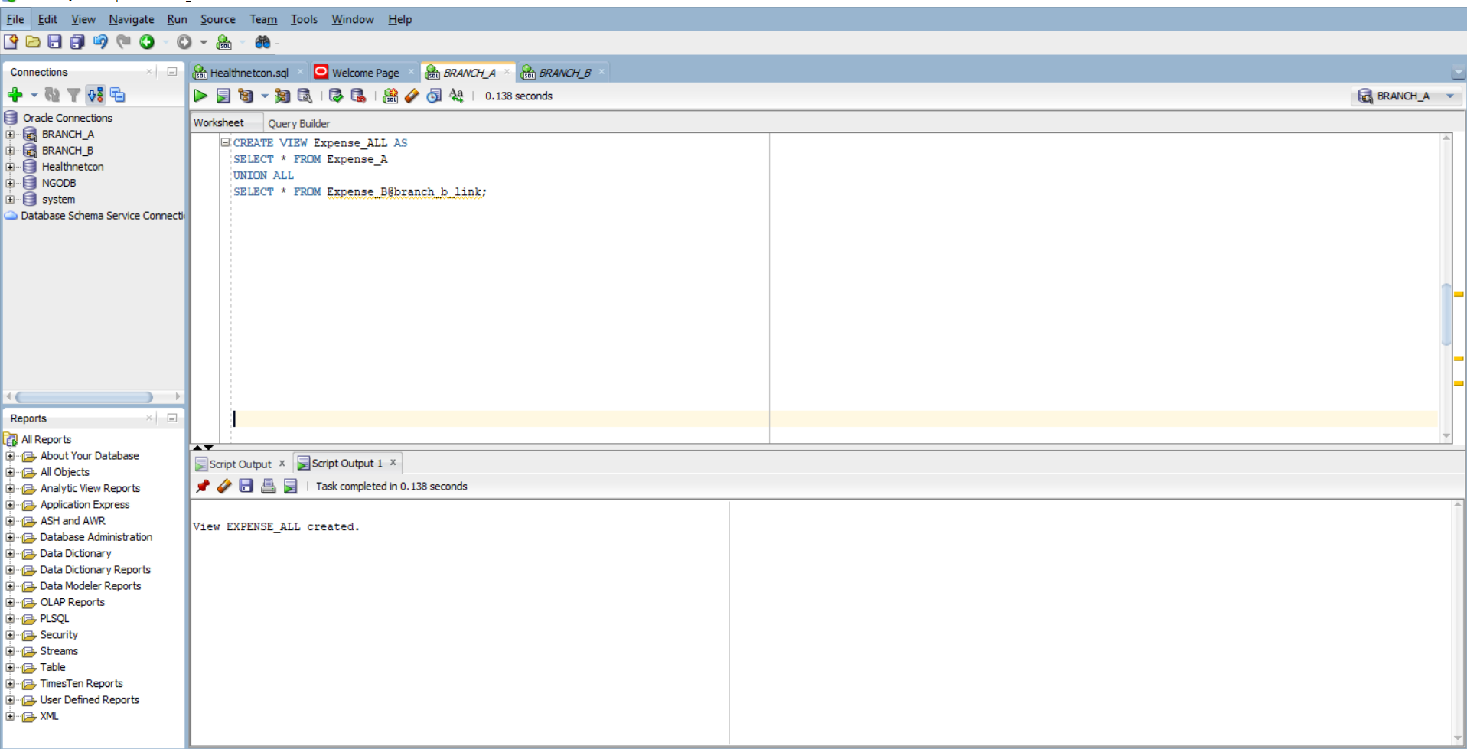

- A. count from fragments

SELECT COUNT(*) FROM Expense_A; -- Should return 5
SELECT COUNT(*) FROM Expense_B@branch_b_link; -- Should return 5

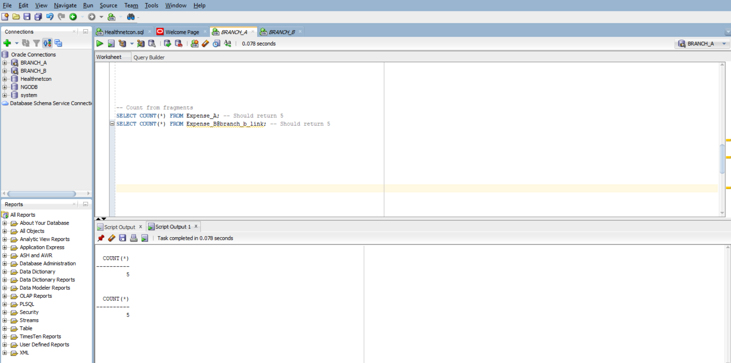

B. count from View

SELECT COUNT(*) FROM Expense_ALL;
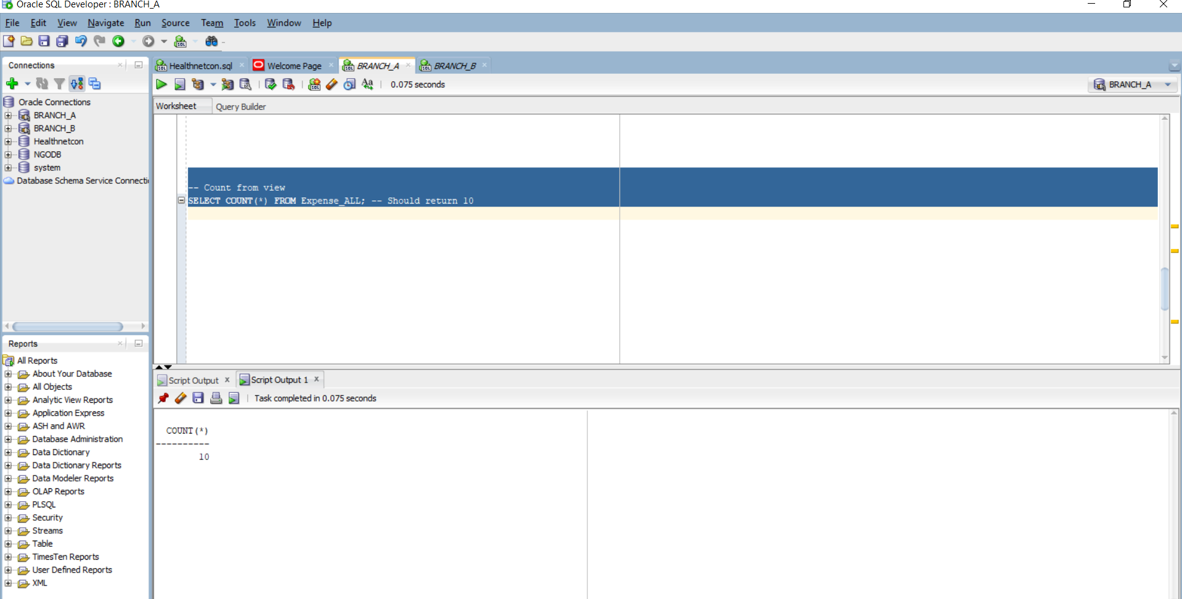

c. Checksum from fragments
SELECT SUM(MOD(Expense_ID, 97)) FROM Expense_A;
SELECT SUM(MOD(Expense_ID, 97)) FROM Expense_B@branch_b_link;
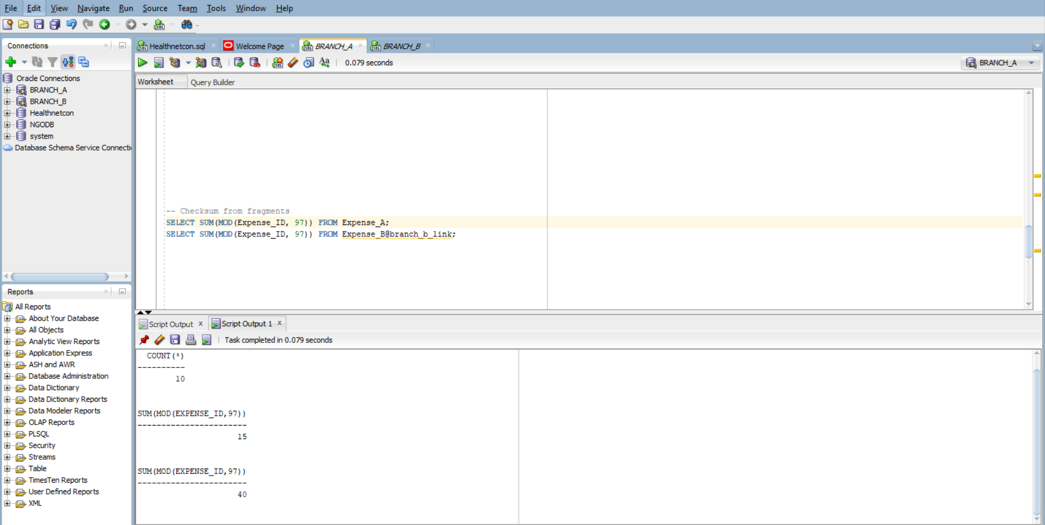

d. Checksum from View

SELECT SUM(MOD(Expense_ID, 97)) FROM Expense_ALL;
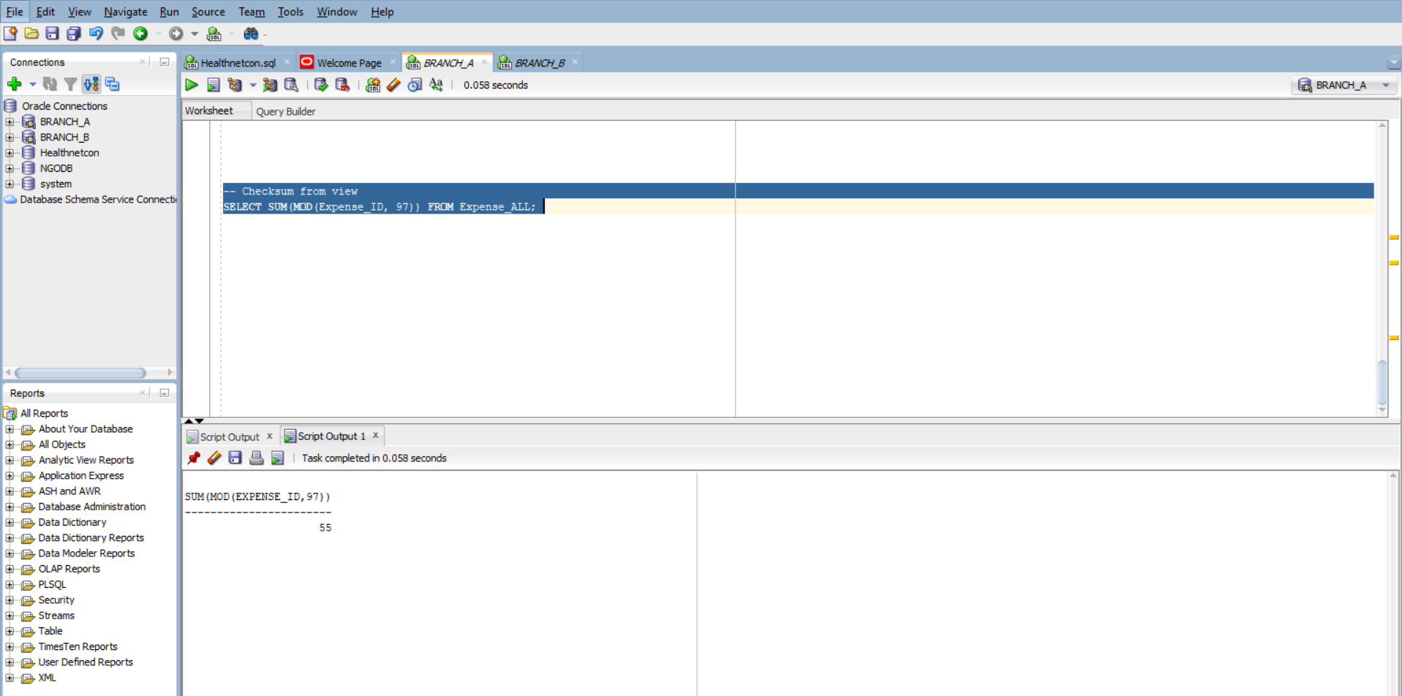

A2 :Database Link & Cross-Node Join

a. creation of database link 'proj_link' to Node_B
CREATE DATABASE LINK proj_link
CONNECT TO branchdb_b IDENTIFIED BY "12345"
USING 'XEPDB1';

b. Remote SELECT on Project@proj_link showing up to 5 sample rows.
SELECT * FROM expense@proj_link
FETCH FIRST 5 ROWS ONLY;
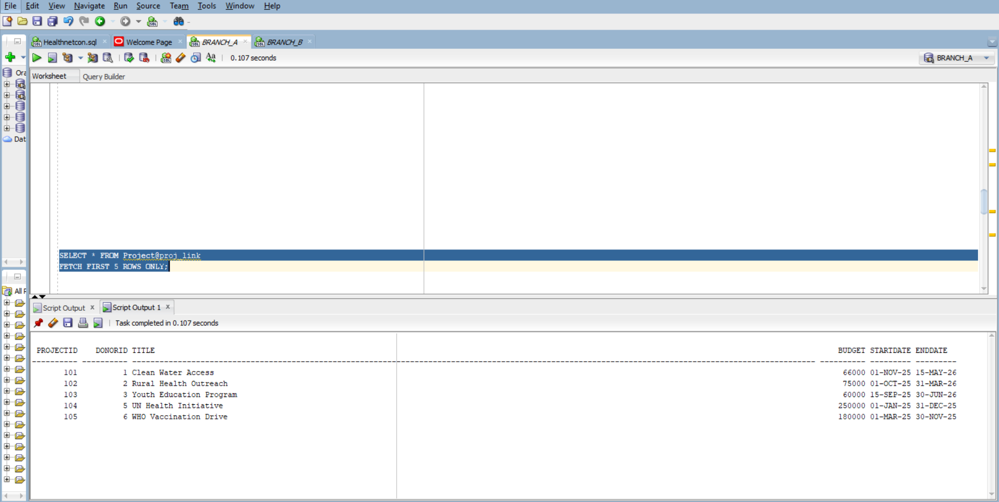

c. Distributed join:

SELECT e.Expense_ID, e.Description, e.Amount, d.Donor_Name, d.Donation_Amount
FROM Expense_A e
CROSS JOIN branchdb_b.Donor@proj_link d
WHERE e.Amount > 100
AND d.Donation_Amount >= 500
AND d.Donation_Date >= DATE '2025-01-01'
FETCH FIRST 10 ROWS ONLY;
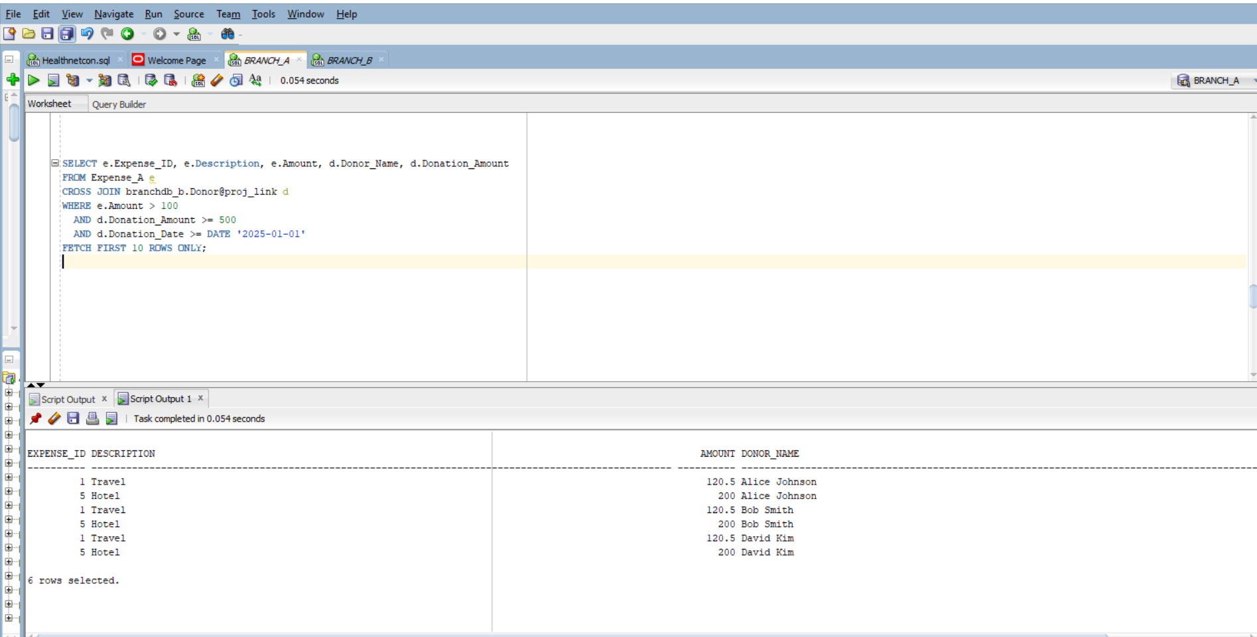

A3 :Parallel vs Serial Aggregation
SERIAL Aggregation on Expense_ALL:

SELECT Description, SUM(Amount) AS Total_Amount
FROM Expense_ALL
GROUP BY Description;
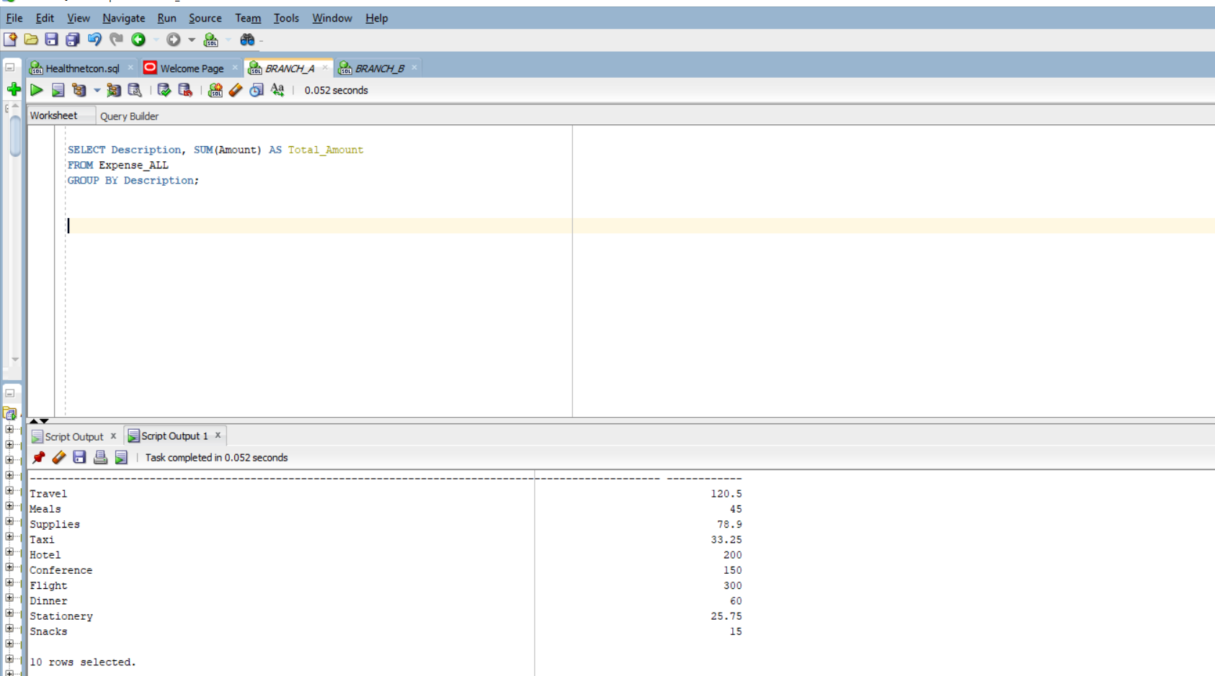

EXPLAIN PLAN FOR
SELECT Description, SUM(Amount) AS Total_Amount
FROM Expense_ALL
GROUP BY Description;

SELECT * FROM TABLE(DBMS_XPLAN.DISPLAY);
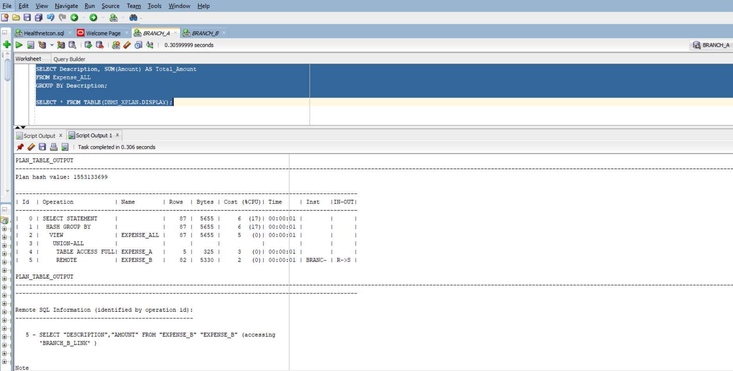

PARALLEL Aggregation

SELECT /*+ PARALLEL(Expense_A,8) PARALLEL(Expense_B,8) */
Description, SUM(Amount) AS Total_Amount
FROM Expense_ALL
GROUP BY Description;
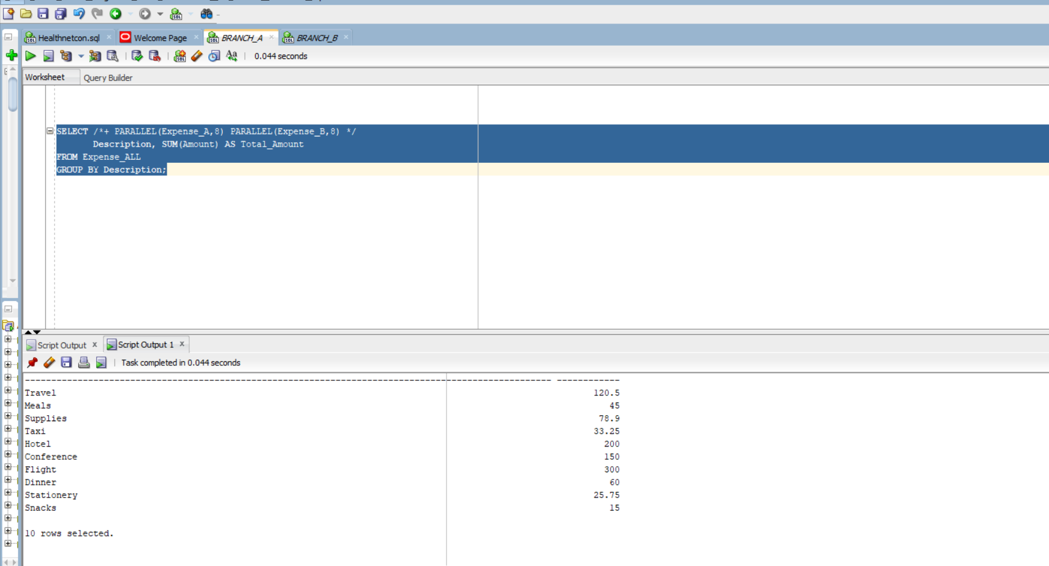

EXPLAIN PLAN FOR
SELECT /*+ PARALLEL(Expense_A,8) PARALLEL(Expense_B,8) */
Description, SUM(Amount) AS Total_Amount
FROM Expense_ALL
GROUP BY Description;

SELECT * FROM TABLE(DBMS_XPLAN.DISPLAY);
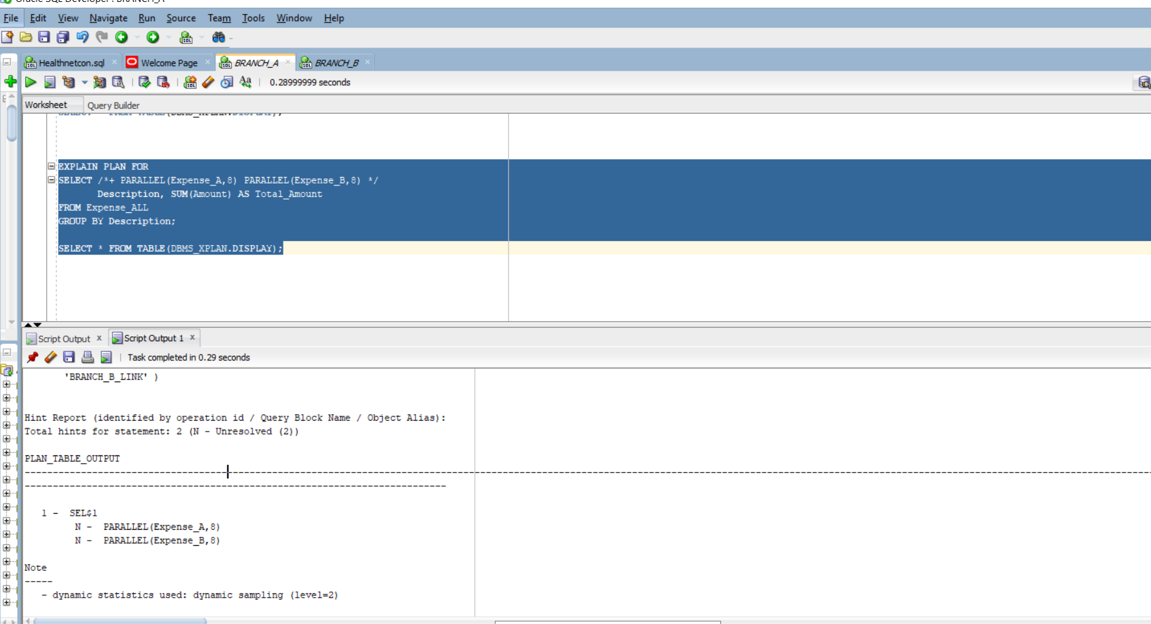

c. Serial Autotrace
SET AUTOTRACE ON STATISTICS
SELECT Description, SUM(Amount) AS Total_Amount
FROM Expense_ALL
GROUP BY Description;
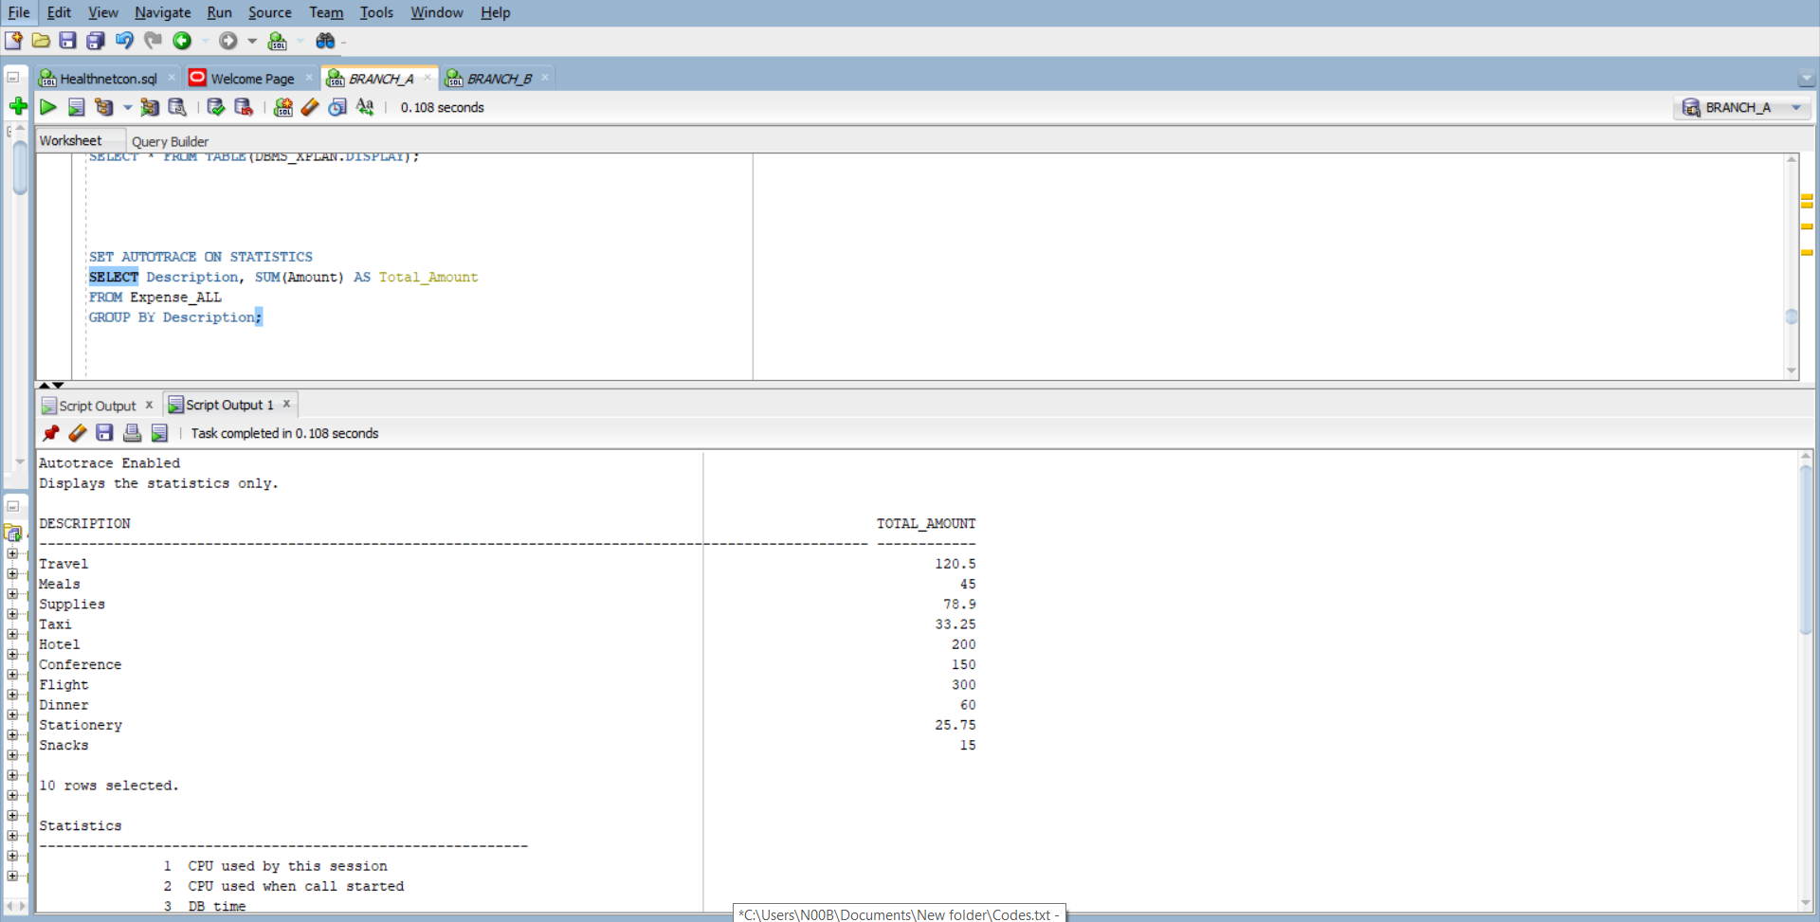

Paerallel Autotrace

SET AUTOTRACE ON STATISTICS
SELECT /*+ PARALLEL(Expense_A,8) PARALLEL(Expense_B,8) */
Description, SUM(Amount) AS Total_Amount
FROM Expense_ALL
GROUP BY Description;
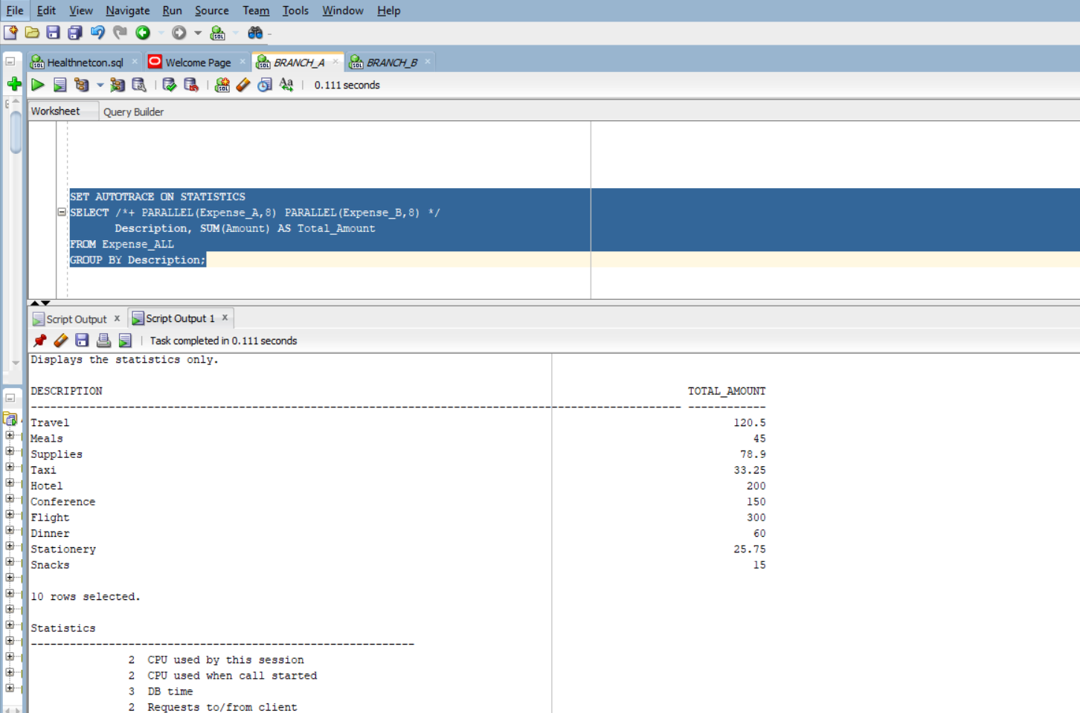

Mode | Execution Plan Notes
Serial | Performs a full table scan on Expense_ALL using a single-threaded aggregation. Minimal CPU and I/O usage. Suitable for small datasets.
Parallel | Executes parallel full scans on Expense_A and Expense_B using multiple PX slaves. Includes PX COORDINATOR, PX SEND, and PX RECEIVE operations. Higher resource allocation, but similar timing due to small data volume.

A4 :Two-Phase Commit & Recovery
- PL/SQL block that inserts ONE local row (related to Expense) on Node_A and ONE remote row into Expense@proj_link
BEGIN
-- Insert into local Expense_A on Node_A
INSERT INTO Expense_A (Expense_ID, Description, Amount)
VALUES (9001, 'Test Local Expense', 123.45);

-- Insert into remote Expense on Node_B via proj_link
INSERT INTO Expense@proj_link (ExpenseID, ProjectID, Description, COST, DateIncurred)
VALUES (9001, 101, 'Test Remote Expense', 123.45, SYSDATE);

COMMIT;
END;
/

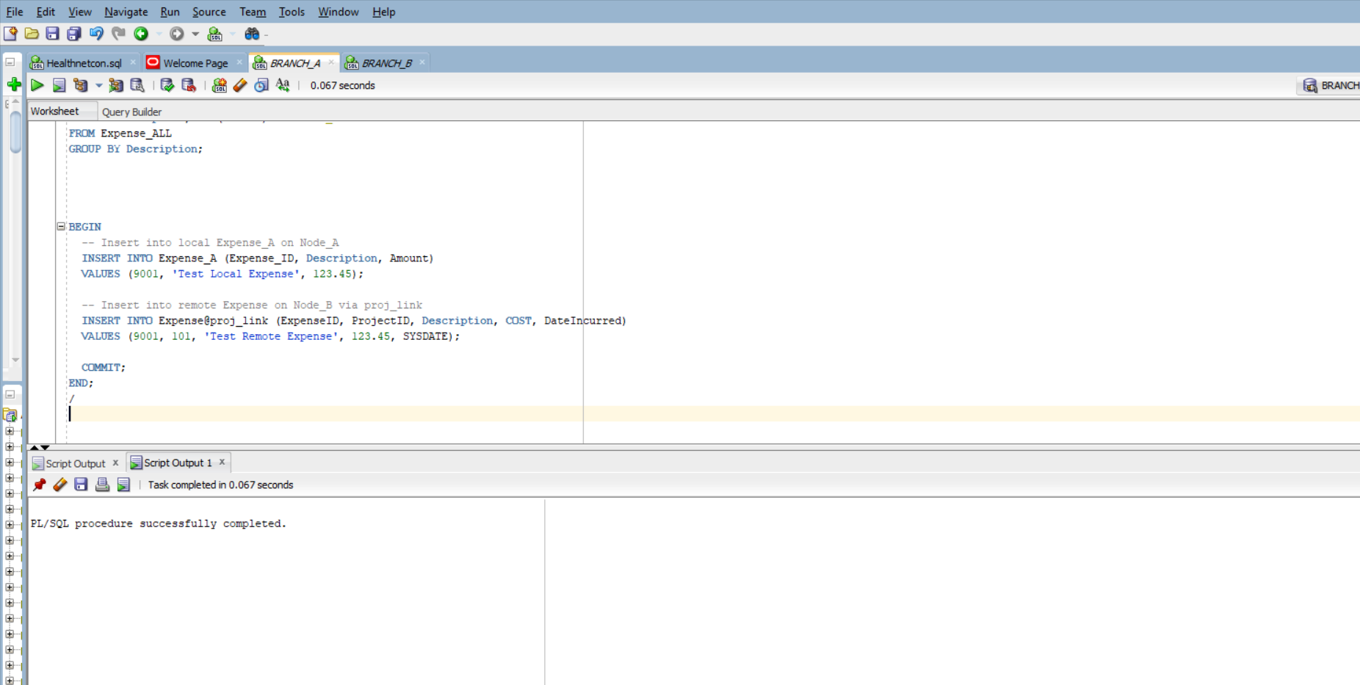

- failure is not possible Oracle, whether remkote or local transaction

BEGIN
INSERT INTO Expense_A (Expense_ID, Description, Amount)
VALUES (9002, 'Failed Local Expense', 999.99);

INSERT INTO Expense@proj_link (ExpenseID, ProjectID, Description, COST, DateIncurred)
VALUES (9002, 102, 'Failed Remote Expense', 999.99, SYSDATE);

COMMIT;
END;
/
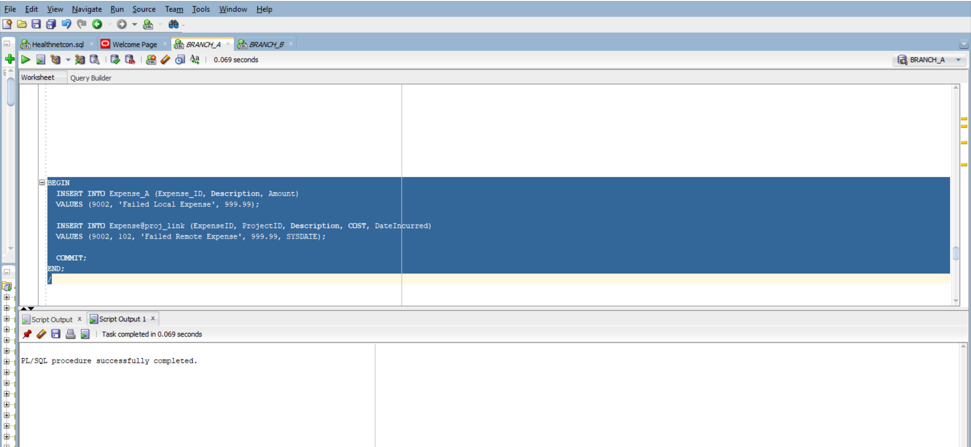

It return no rows beacause the transaction went through: Query DBA_2PC_PENDING

SELECT LOCAL_TRAN_ID, GLOBAL_TRAN_ID, STATE
FROM DBA_2PC_PENDING;
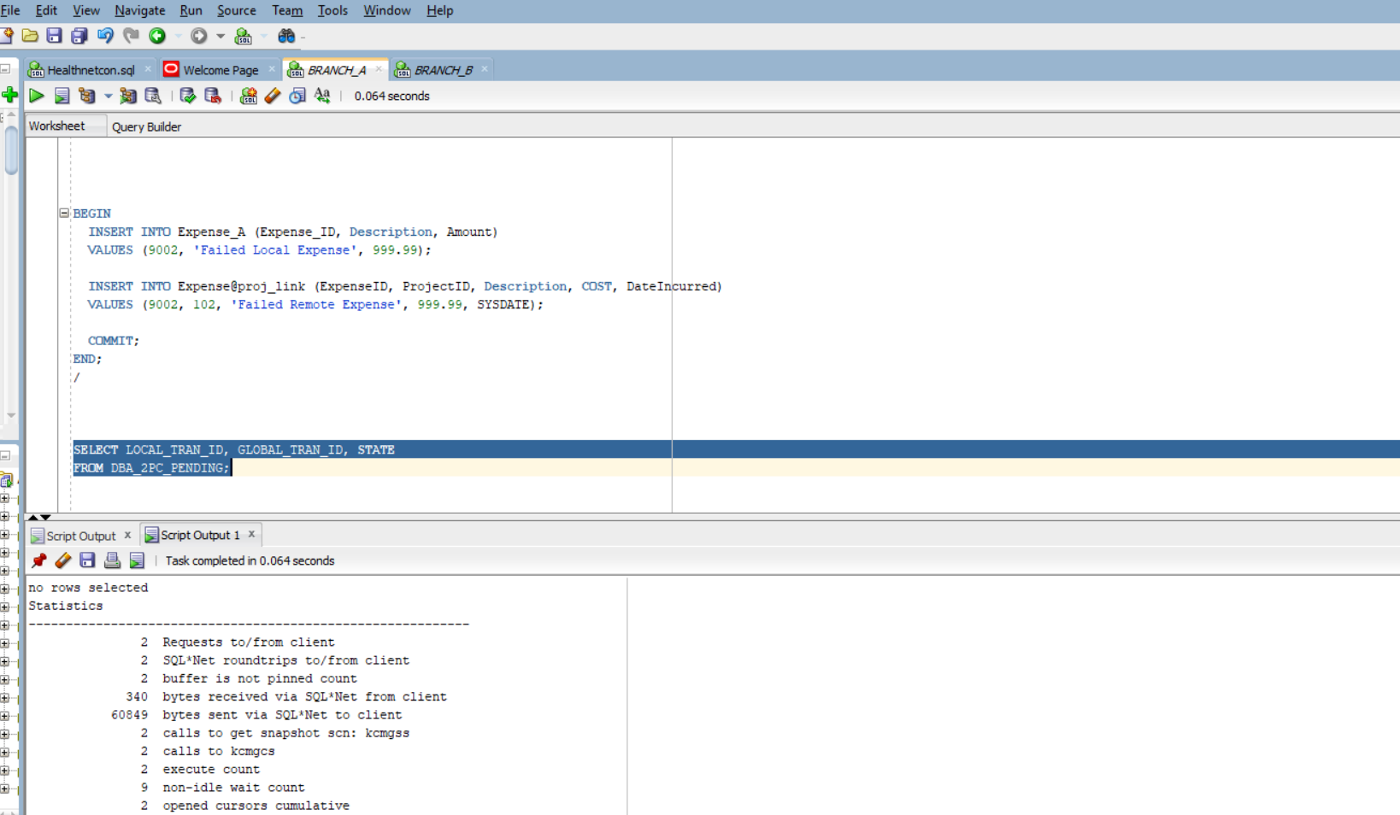

d. No need to roll back since no transaction is hanging
e. inserted row
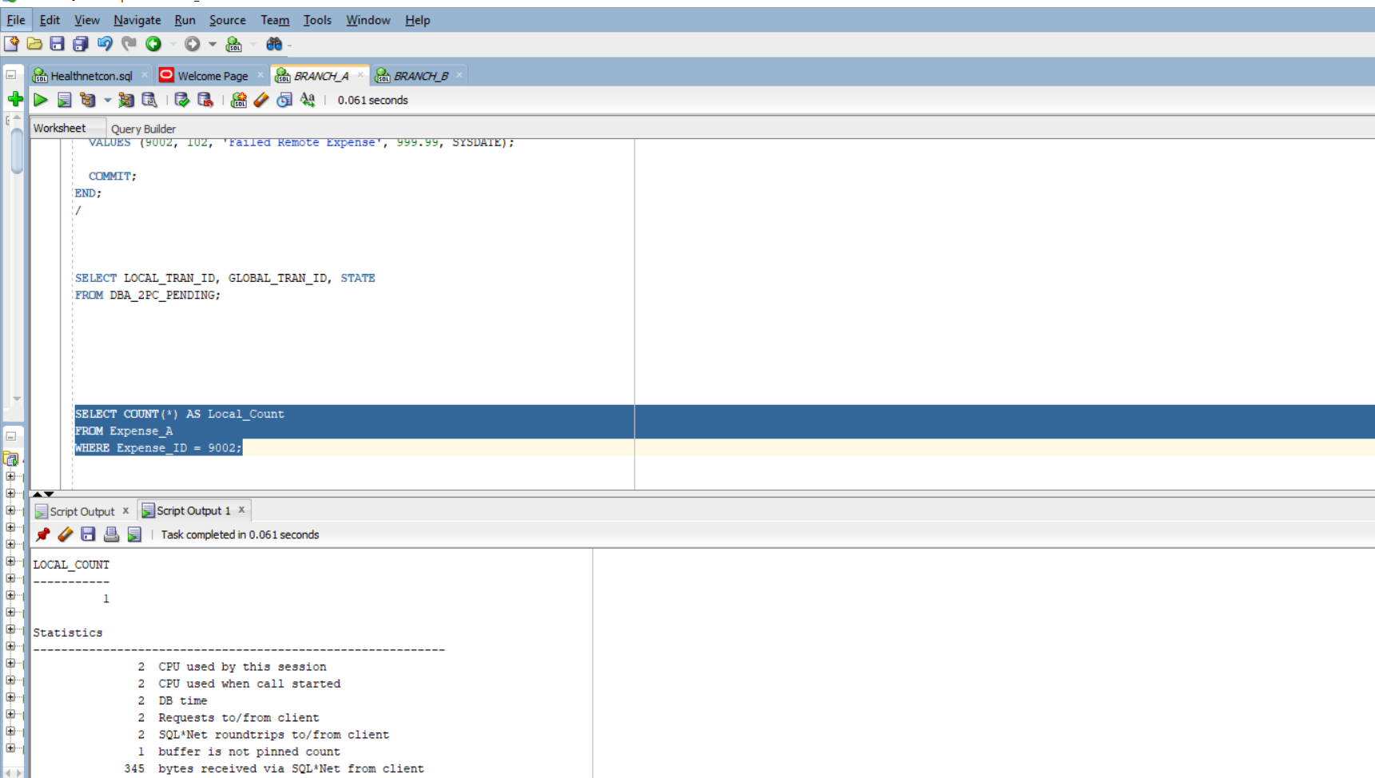

A5 :Distributed Lock Conflict & Diagnosis

- Open Session 1 on Node_A:UPDATE a single row in project

BEGIN

UPDATE Project
SET Budget = 5000
WHERE ProjectID = 101;

DBMS_LOCK.SLEEP(120);

COMMIT;

END;
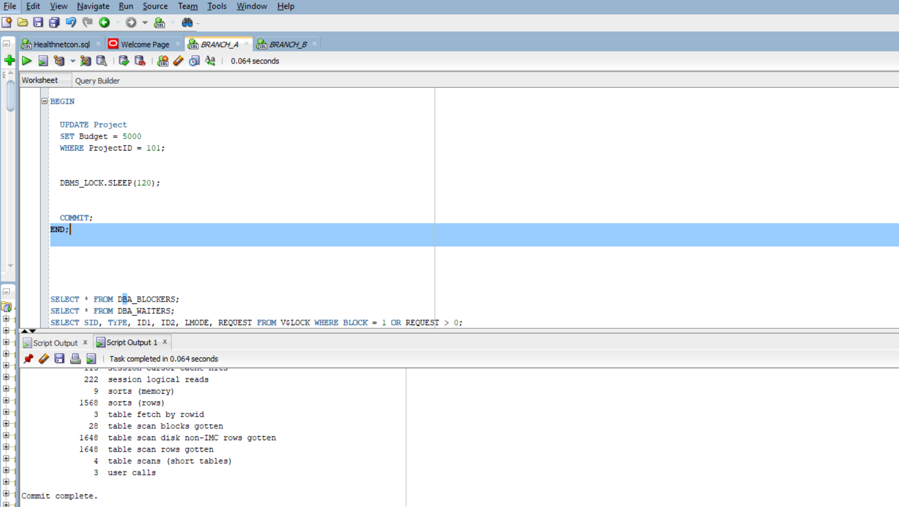

b. Open Session 2on Node_B:UPDATE remotely a single row in Project

BEGIN

UPDATE Project@BRANCH_A_LINK
SET Budget = 5000
WHERE ProjectID = 101;

DBMS_LOCK.SLEEP(120);

COMMIT;

END;

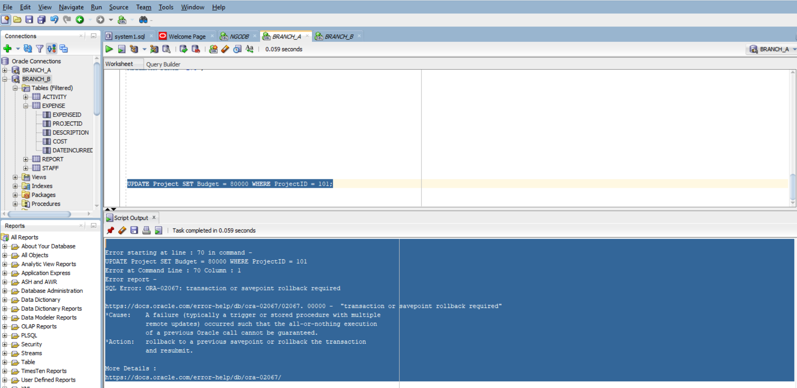

- View Locks
SELECT SID, TYPE, ID1, ID2, LMODE, REQUEST, BLOCK
FROM V$LOCK
WHERE BLOCK = 1 OR REQUEST > 0;
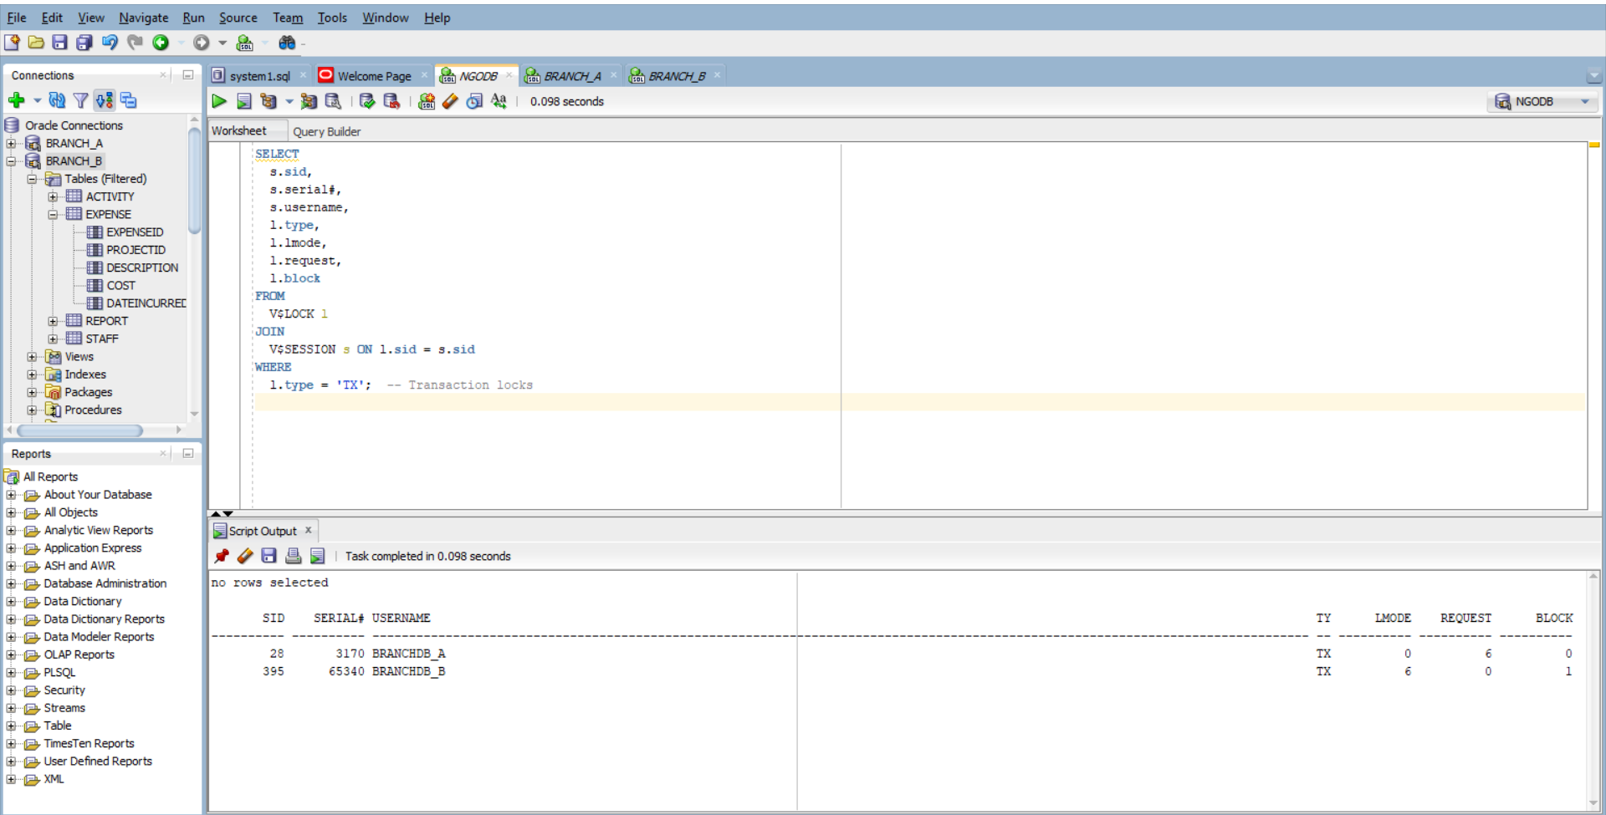

- Release the lock
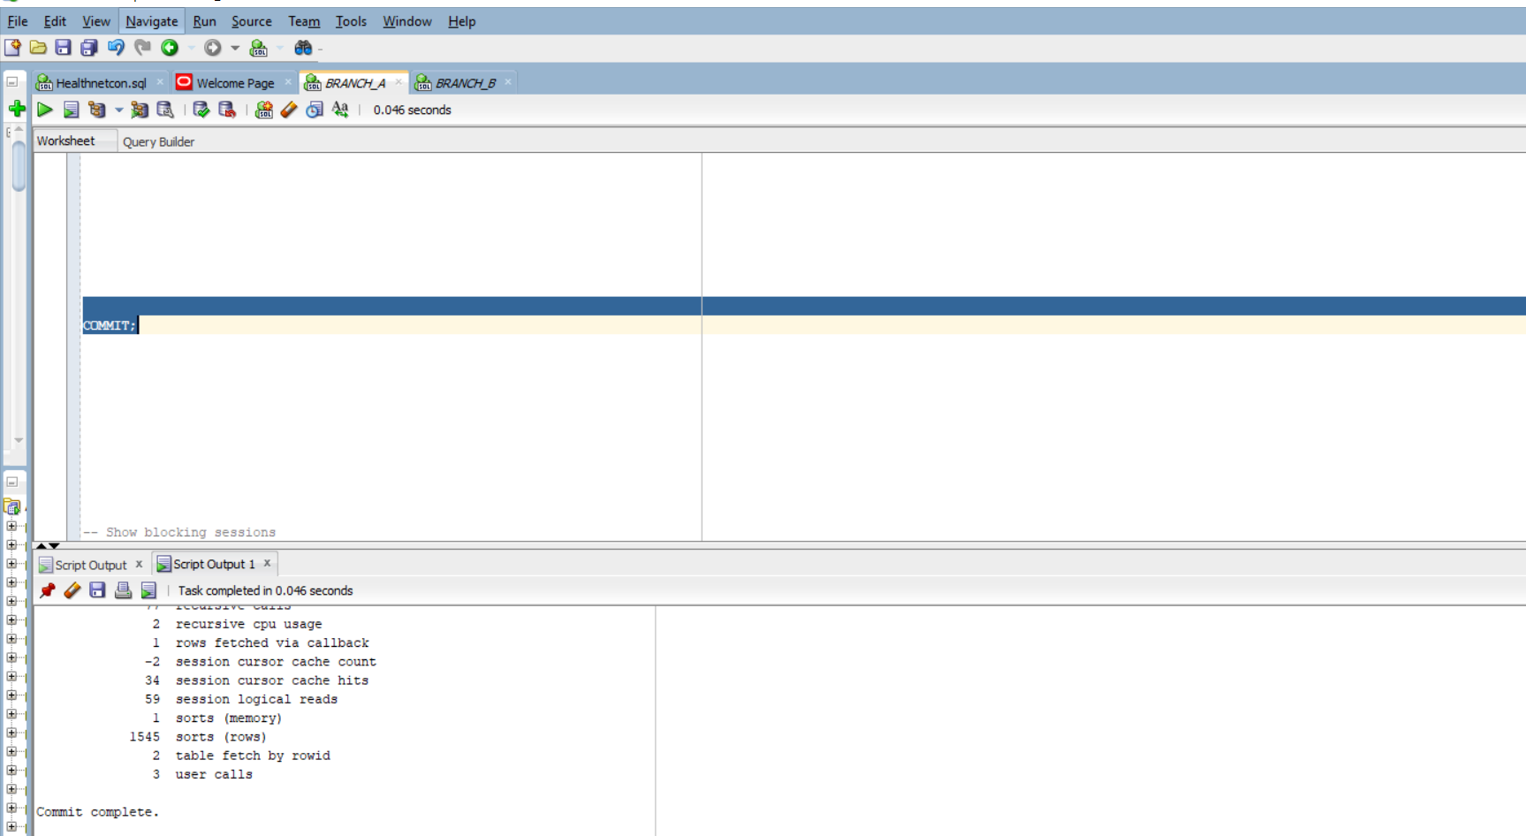

B6 :Declarative Rules Hardening
- Project and Expense, add/verify NOT NULL and domain CHECK constraints
-Add constraints to Project table:
ALTER TABLE Project
MODIFY (Budget NUMBER NOT NULL);

ALTER TABLE Project
ADD CONSTRAINT chk_project_budget_positive CHECK (Budget > 0);

ALTER TABLE Project
ADD CONSTRAINT chk_project_dates_valid CHECK (StartDate < EndDate);

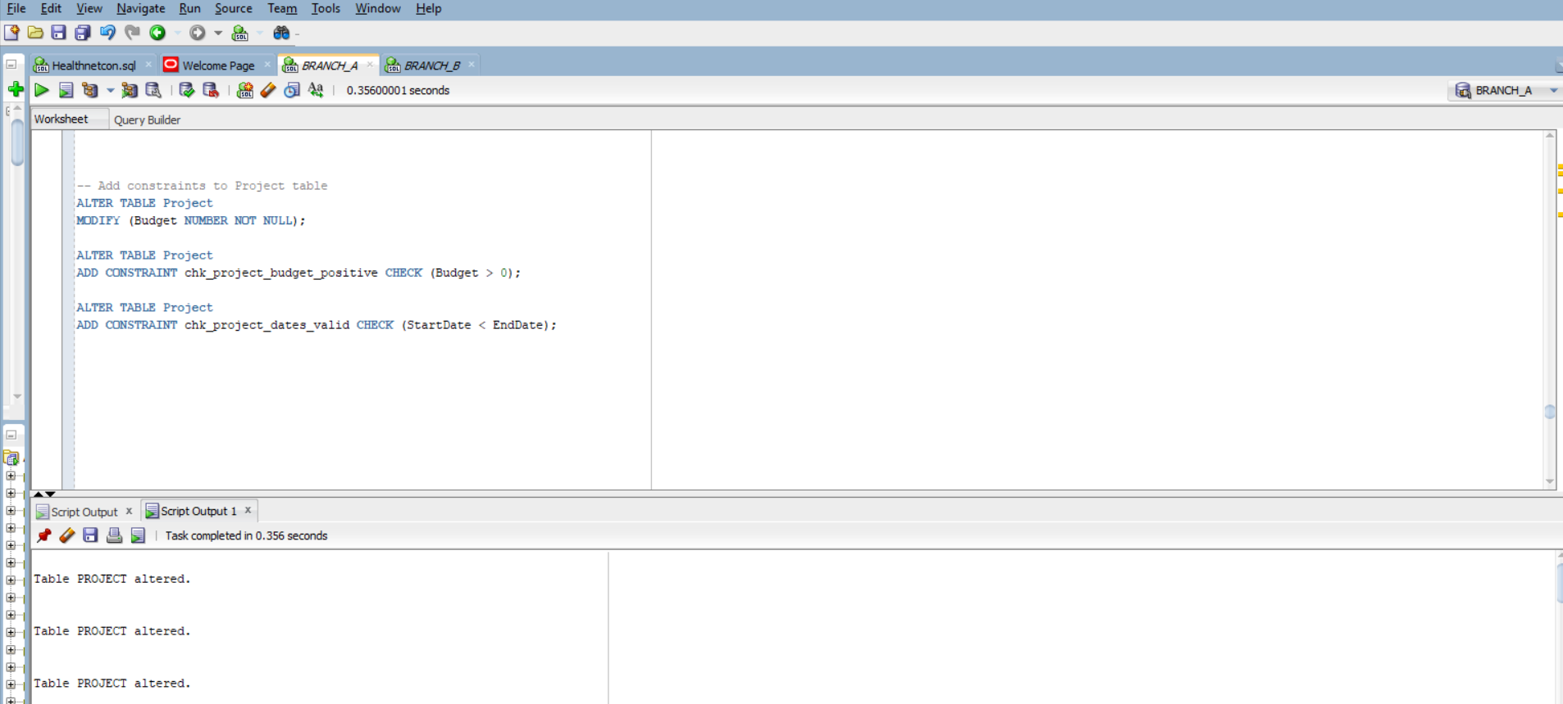
Ensure essential columns are not null:

ALTER TABLE Expense_A
MODIFY (Expense_ID NUMBER NOT NULL,
Description VARCHAR2(100) NOT NULL,
Amount NUMBER NOT NULL);

Add domain constraint: Amount must be positive:
ALTER TABLE Expense_a
ADD CONSTRAINT chk_expense_amount_positive CHECK (Amount > 0);

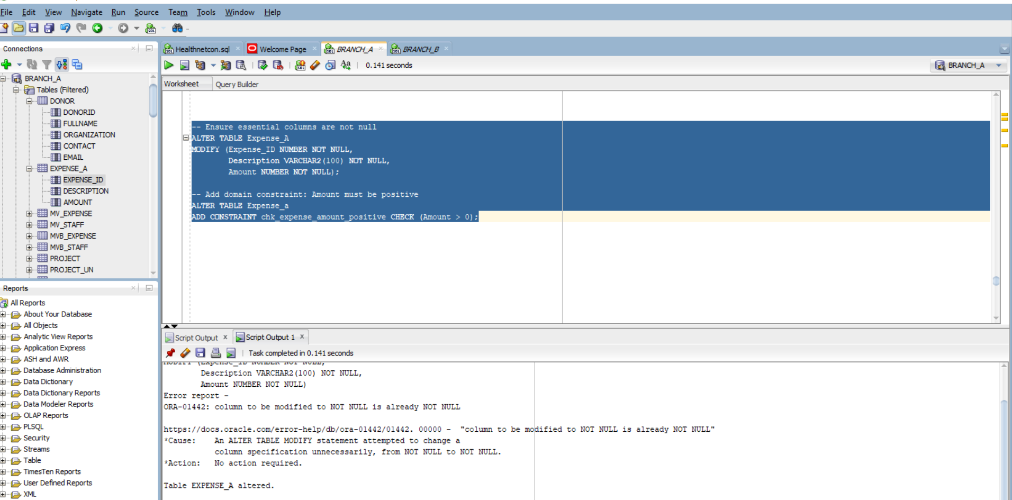

- Successful inserts
INSERT INTO expense_a (Expense_ID, Description, Amount)
VALUES (101, 'Office Supplies', 250);

INSERT INTO Expense_a (Expense_ID, Description, Amount)
VALUES (102, 'Training Materials', 500);
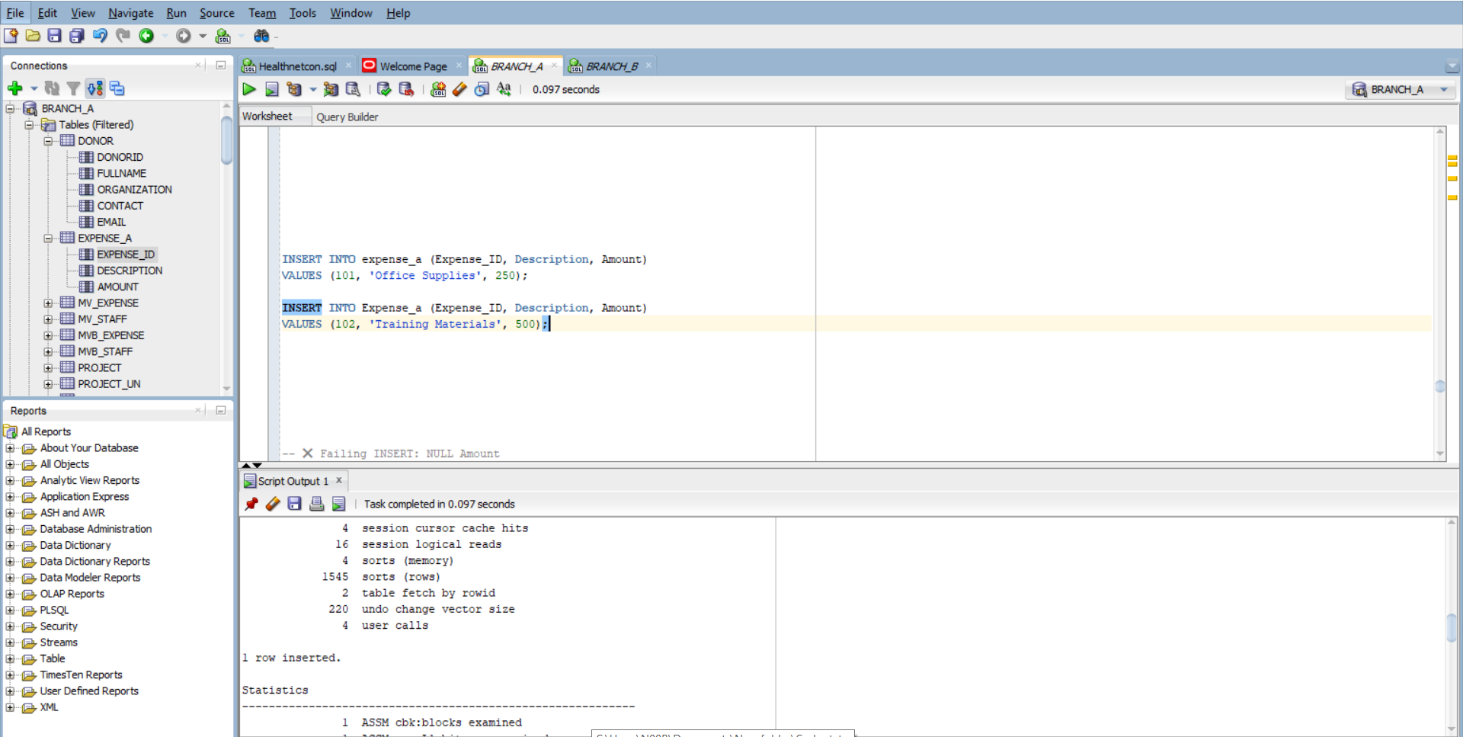
Show committed rows
SELECT Expense_ID, Description, Amount FROM expense_a
WHERE Expense_ID IN (101, 102);

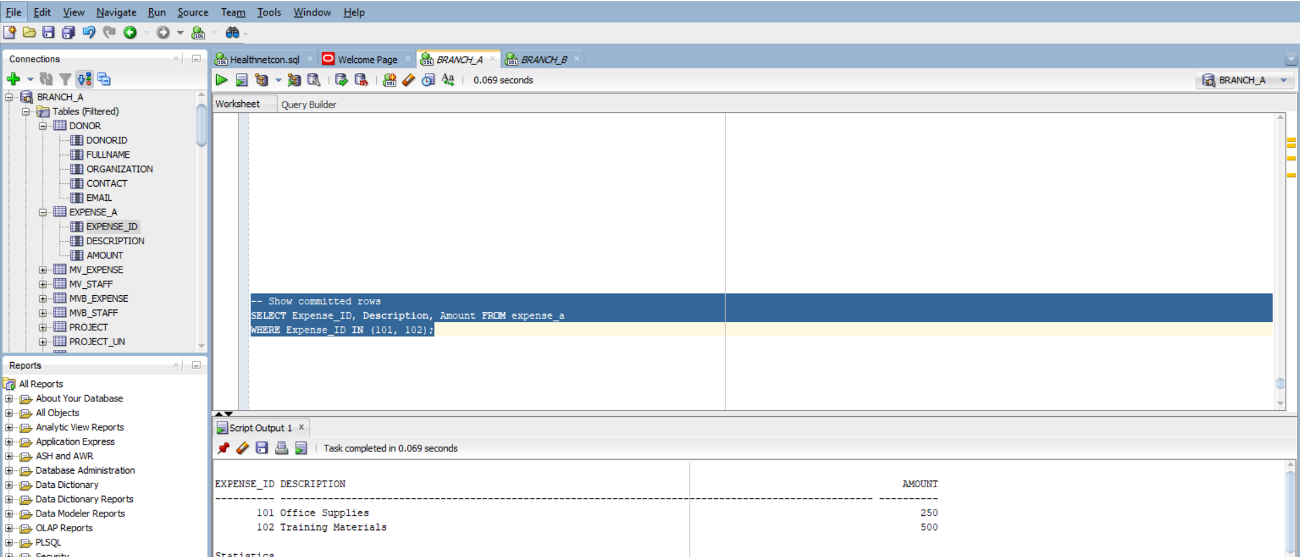
Failed inserts
BEGIN
INSERT INTO Expense (ExpenseID, Description, Amount)
VALUES (103, 'Missing Amount', NULL);
EXCEPTION
WHEN OTHERS THEN
DBMS_OUTPUT.PUT_LINE('Insert failed (NULL Amount): ' || SQLERRM);
ROLLBACK;
END;
/
Failing INSERT 2: NULL Amount

BEGIN
INSERT INTO Expense (ExpenseID, Description, Amount)
VALUES (104, 'Negative Expense', -100);
EXCEPTION
WHEN OTHERS THEN
DBMS_OUTPUT.PUT_LINE('Insert failed (Negative Amount): ' || SQLERRM);
ROLLBACK;
END;
/

Failing INSERT 1: Negative Amount

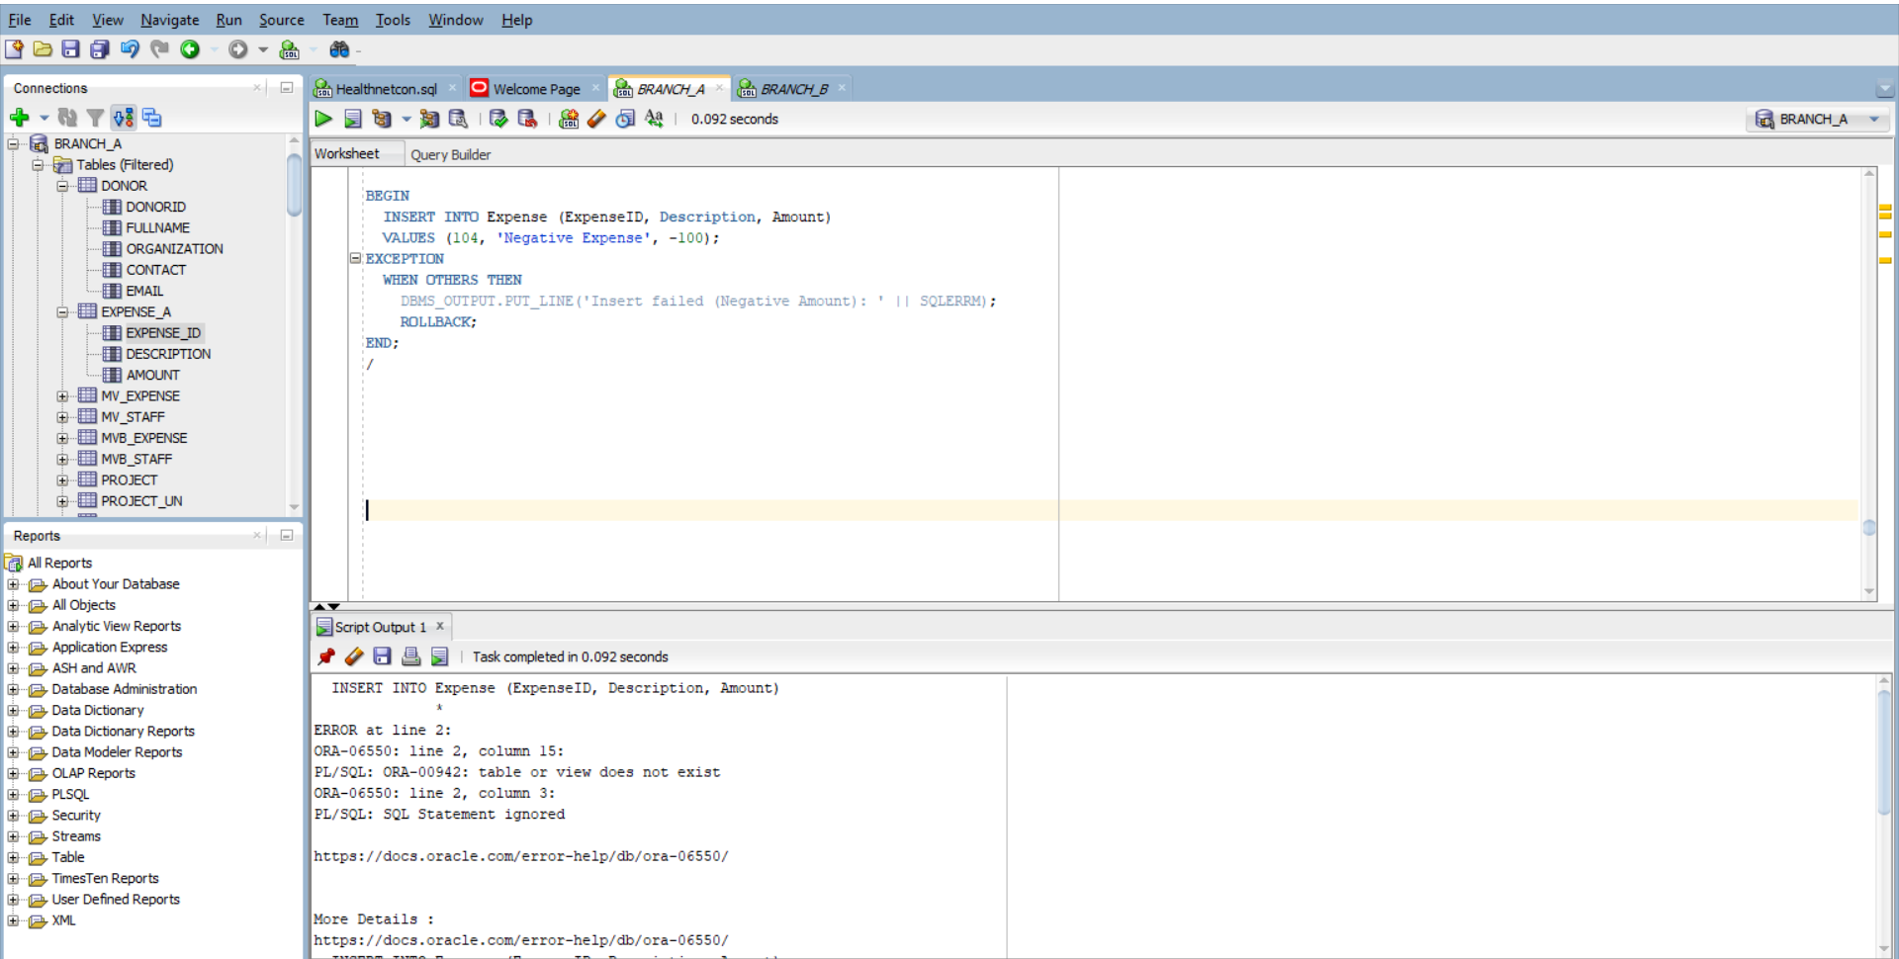
-- Confirm total committed rows ≤10
SELECT COUNT(*) FROM Expense_a;
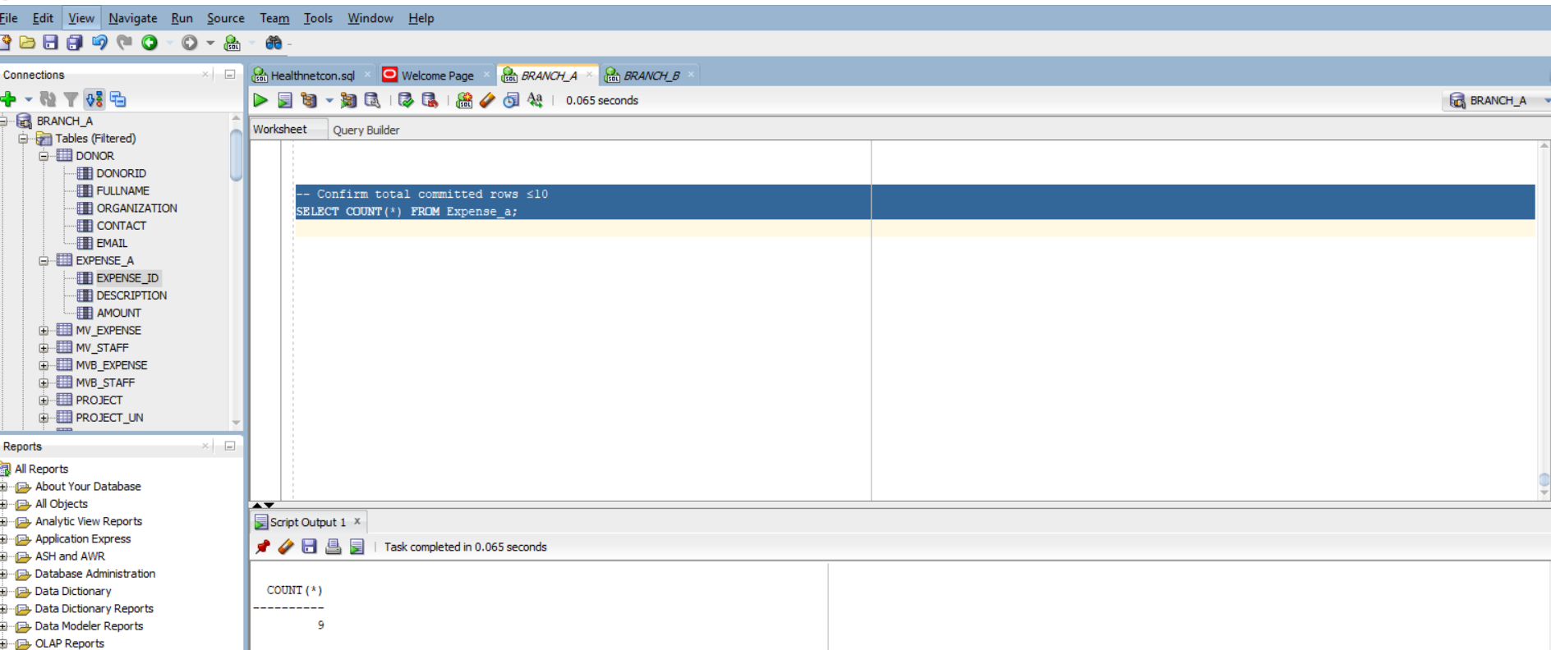

B7 :E–C–A Trigger for Denormalized Totals
- Create an audit table Project_AUDIT

CREATE TABLE Project_AUDIT (
bef_total NUMBER,
aft_total NUMBER,
changed_at TIMESTAMP DEFAULT SYSTIMESTAMP,
key_col VARCHAR2(64)
);

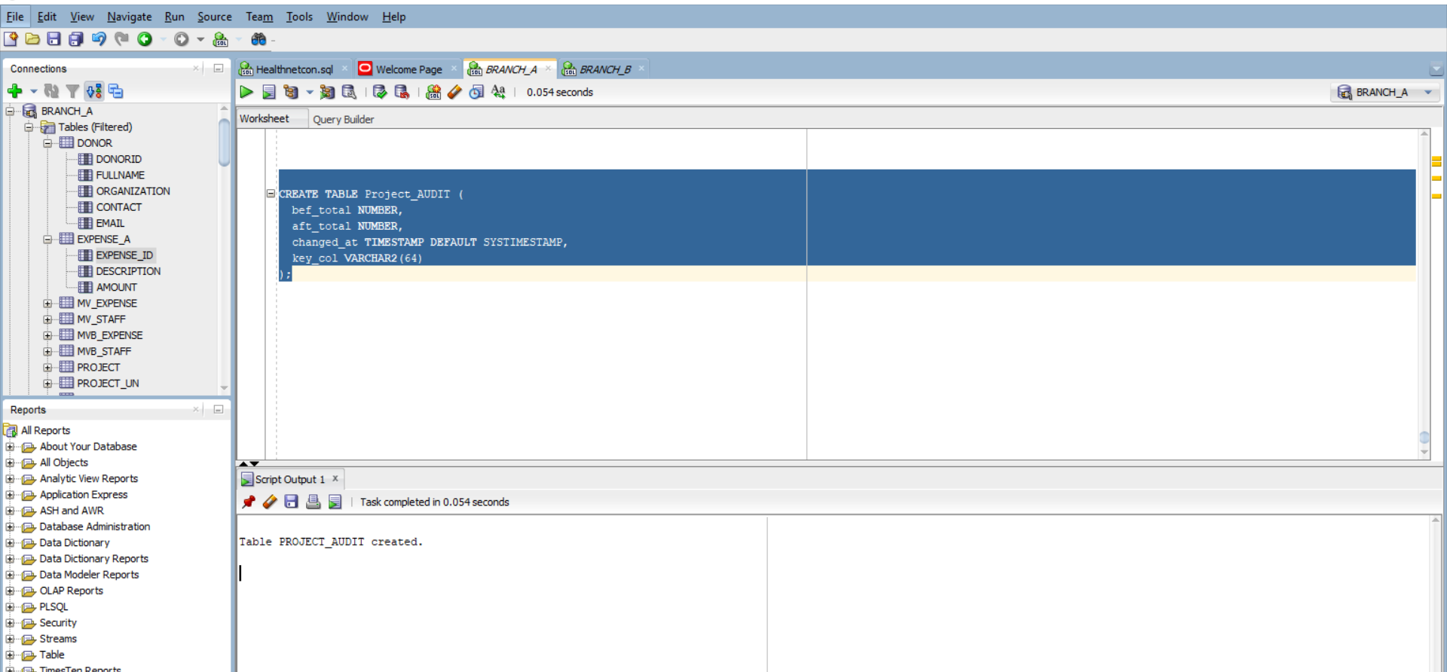

- This trigger assumes Expense has a column ProjectCode that links it to Project.

CREATE OR REPLACE TRIGGER trg_expense_recompute_budget
AFTER INSERT OR UPDATE OR DELETE ON Expense_a
DECLARE
v_code VARCHAR2(64);
v_bef_total NUMBER;
v_aft_total NUMBER;
BEGIN
-- Get one affected ProjectCode
SELECT ProjectCode INTO v_code FROM Expense_a WHERE ROWNUM = 1;

-- Get current budget from Project
SELECT Budget INTO v_bef_total FROM Project WHERE ProjectCode = v_code;

-- Recompute total from Expense
SELECT NVL(SUM(Amount), 0) INTO v_aft_total FROM Expense_A WHERE ProjectCode = v_code;

-- Update Project budget
UPDATE Project SET Budget = v_aft_total WHERE ProjectCode = v_code;

-- Log audit entry
INSERT INTO Project_AUDIT (bef_total, aft_total, key_col)
VALUES (v_bef_total, v_aft_total, v_code);
END;
/

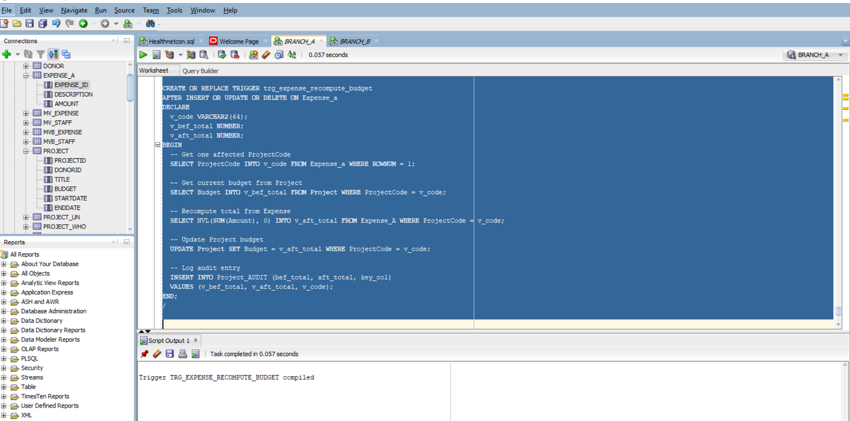

- Insert 2 expenses

INSERT INTO Expense_a (Expense_ID, Description, Amount, ProjectCode)
VALUES (1001, 'Venue Rental', 2000, 'P001');

INSERT INTO Expense_a (Expense_ID, Description, Amount, ProjectCode)
VALUES (1002, 'Catering', 1500, 'P001');

UPDATE Expense_a
SET Amount = 1800
WHERE Expense_ID = 1001;

DELETE FROM Expense_a
WHERE Expense_ID = 1002;

COMMIT;

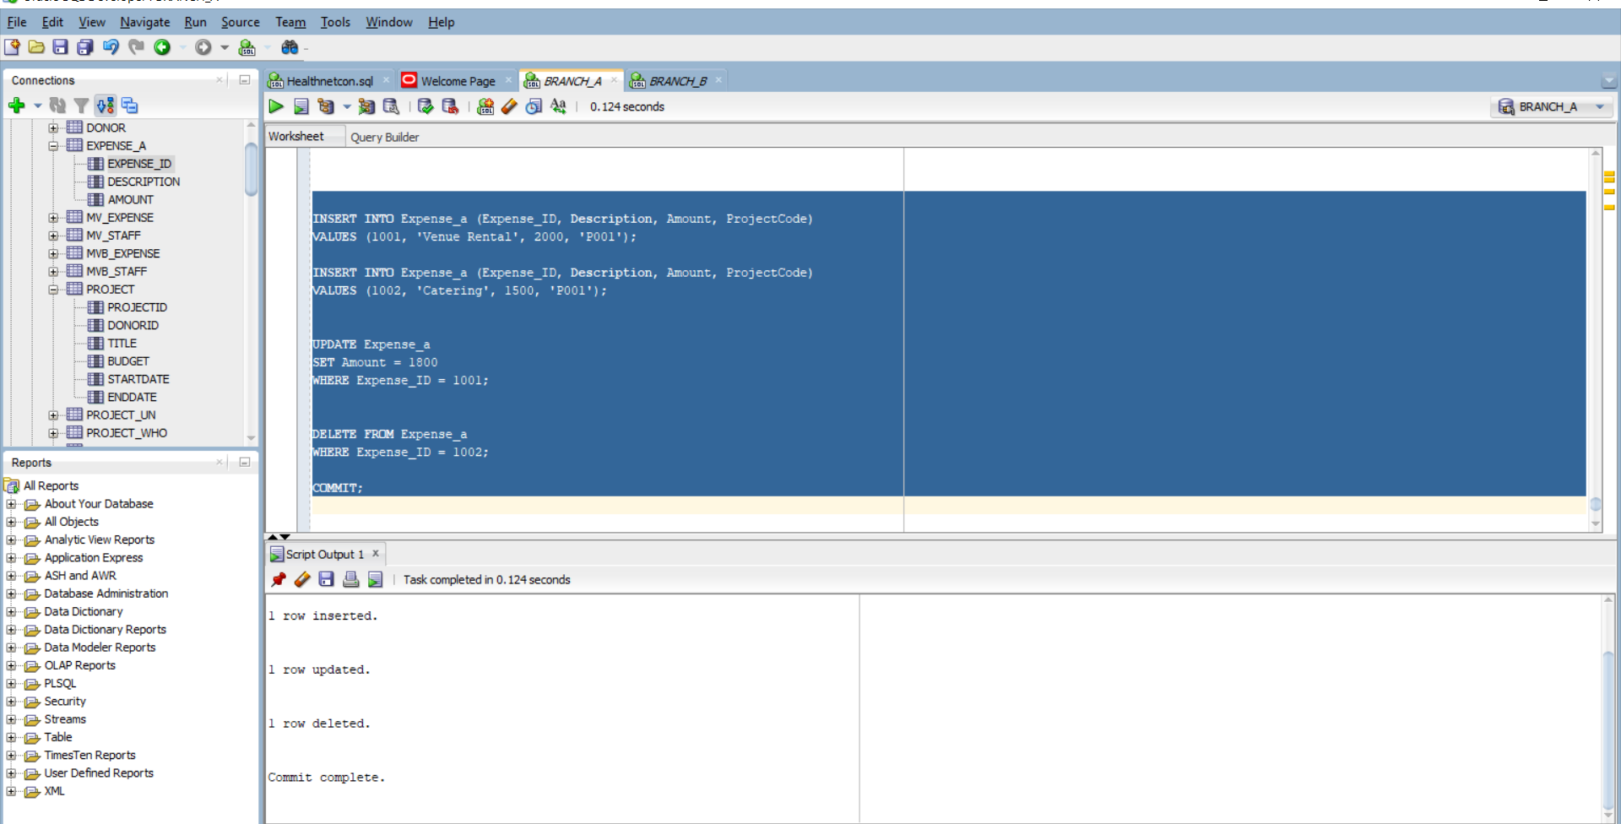
- Check current expenses for P001:
SELECT * FROM Expense_a WHERE ProjectCode = 'P001';
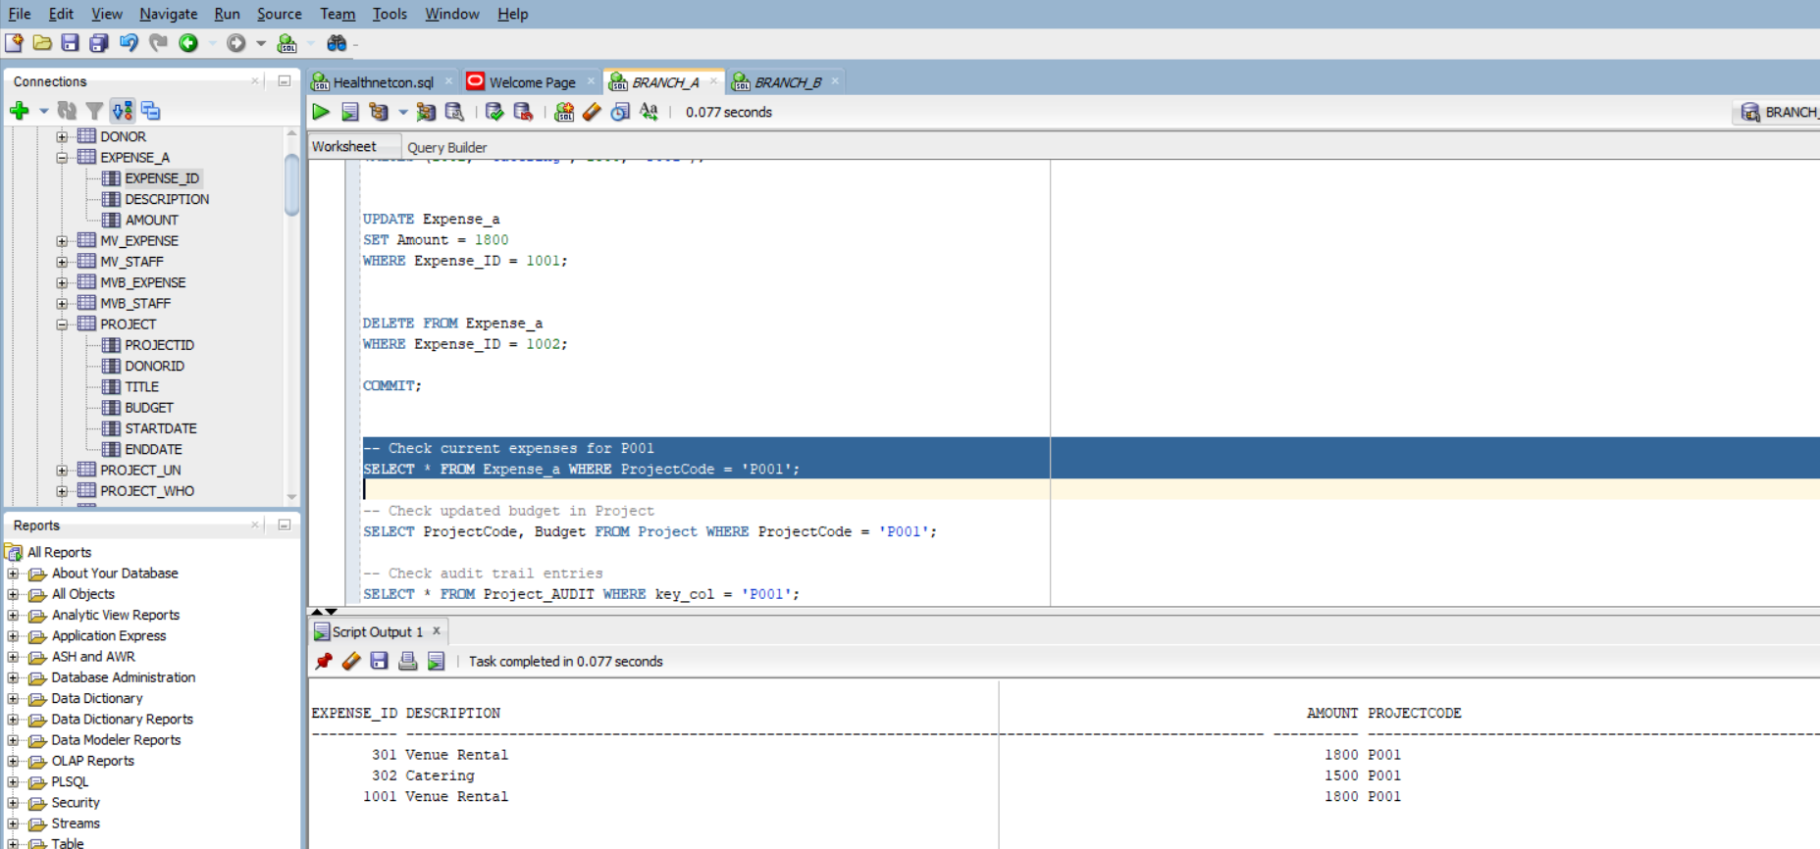

Check updated budget in Project:
SELECT ProjectCode, Budget FROM Project WHERE ProjectCode = 'P001';
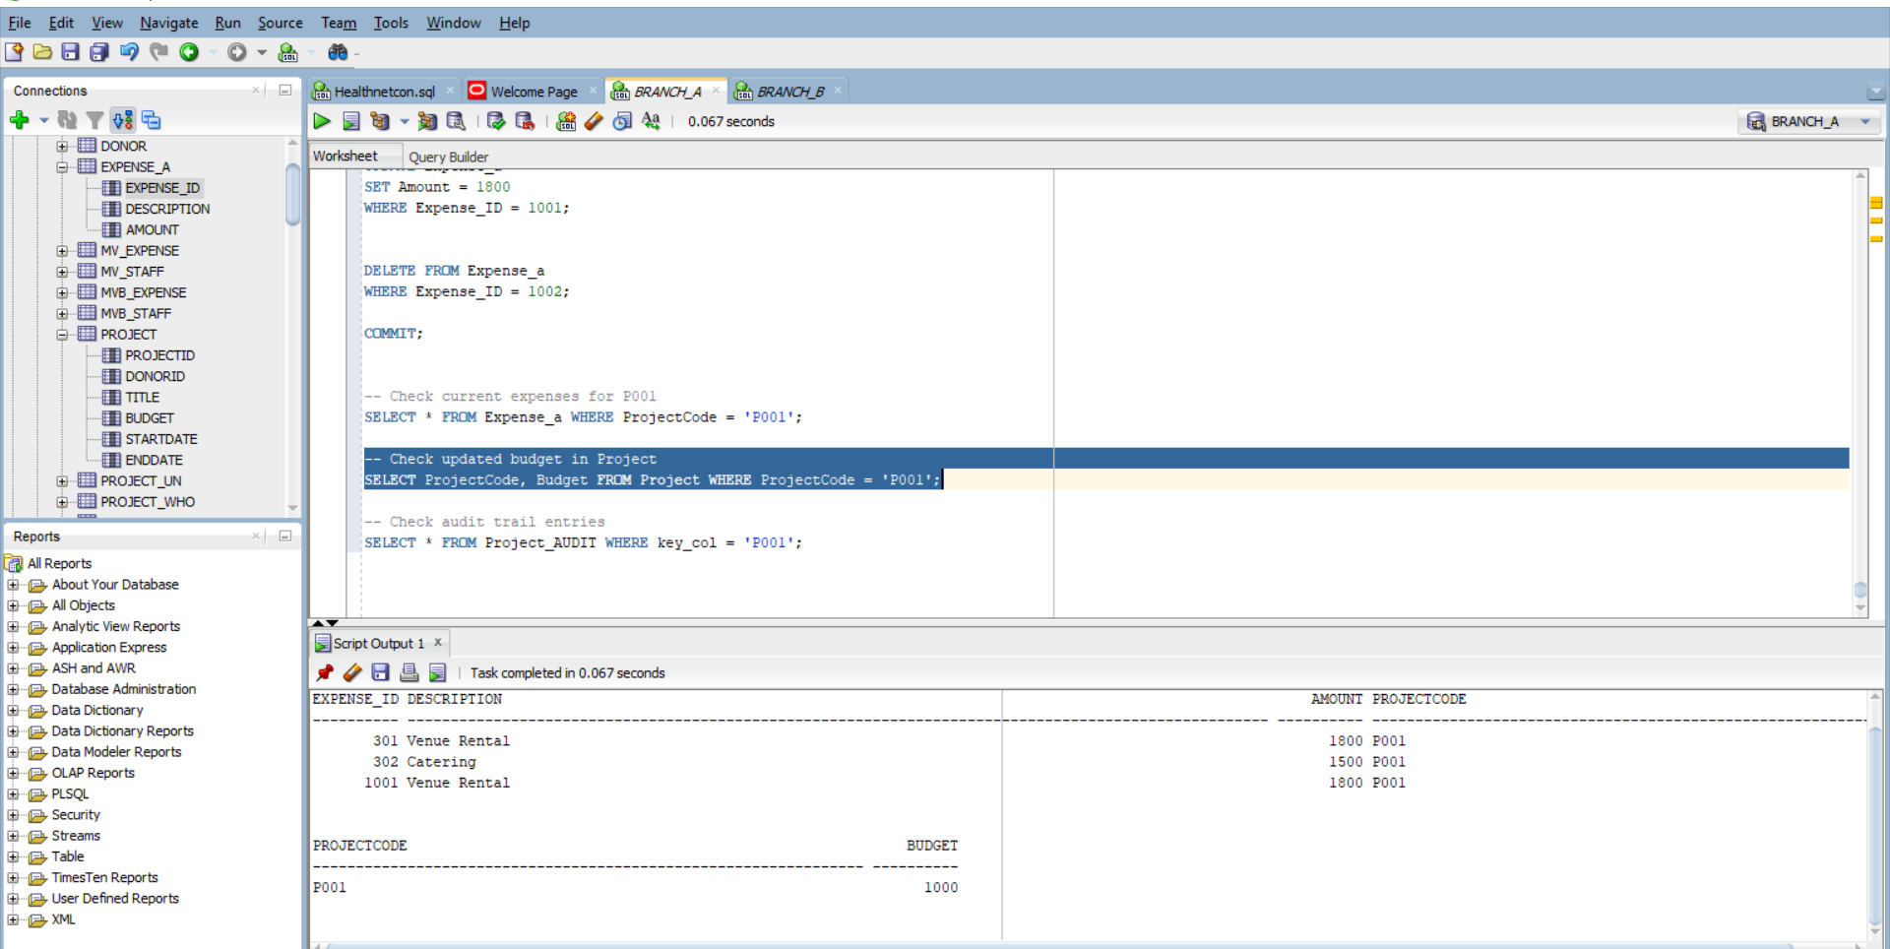

B8: Recursive Hierarchy Roll-Up

- Creating table
CREATE TABLE HIER (
parent_id VARCHAR2(10),
child_id VARCHAR2(10)
);
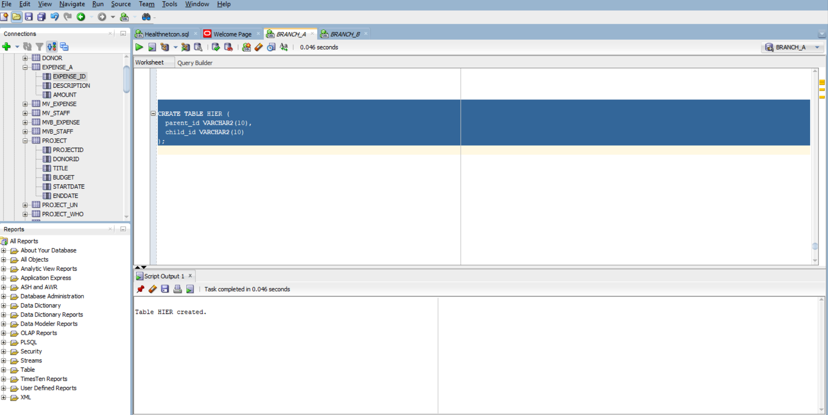

b.

-- Level 1: Root
INSERT INTO HIER VALUES (NULL, 'P001'); -- Main Project

-- Level 2: Departments
INSERT INTO HIER VALUES ('P001', 'D01'); -- Logistics
INSERT INTO HIER VALUES ('P001', 'D02'); -- Operations

-- Level 3: Sub-projects
INSERT INTO HIER VALUES ('D01', 'S01'); -- Transport
INSERT INTO HIER VALUES ('D01', 'S02'); -- Storage
INSERT INTO HIER VALUES ('D02', 'S03'); -- Procurement
INSERT INTO HIER VALUES ('D02', 'S04'); -- Maintenance
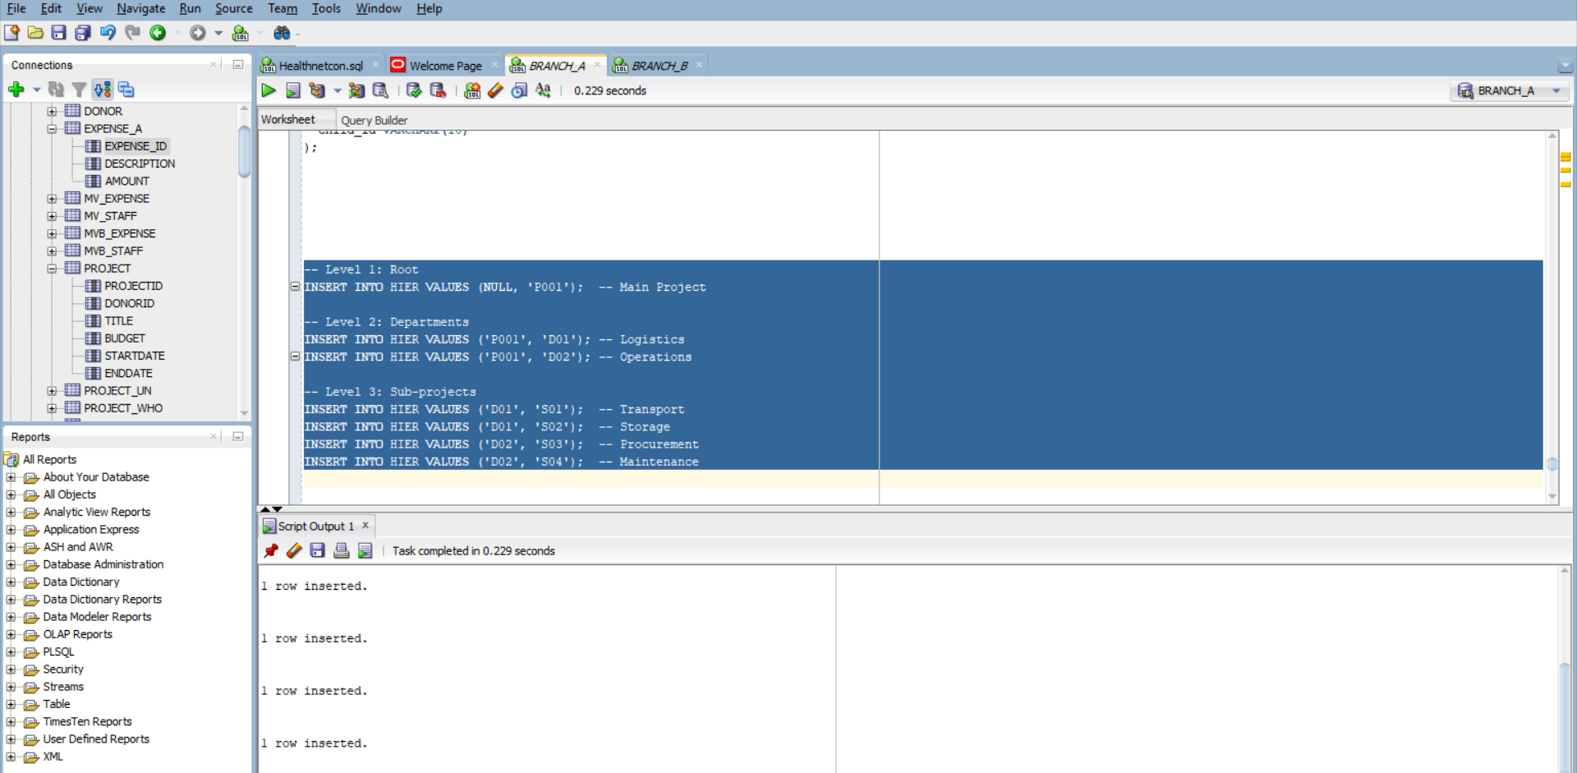

c. Join to Expense_a and Compute Rollups:
WITH hierarchy (child_id, root_id, depth) AS (
-- Anchor: root nodes
SELECT child_id, child_id AS root_id, 0 AS depth
FROM HIER
WHERE parent_id IS NULL

UNION ALL

-- Recursive step
SELECT h.child_id, hr.root_id, hr.depth + 1
FROM HIER h
JOIN hierarchy hr ON h.parent_id = hr.child_id
)
SELECT * FROM hierarchy;
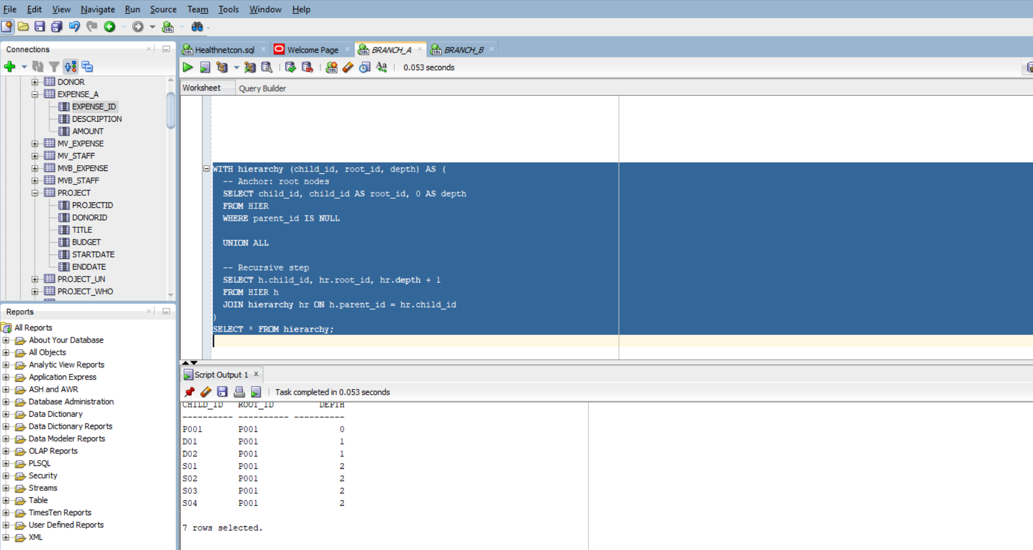

- Join to Expense_a and Compute Rollups
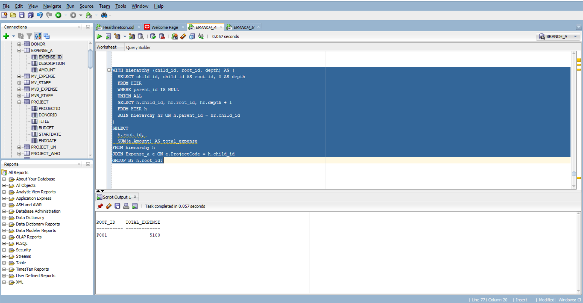

B9 :Mini-Knowledge Base with Transitive Inference
- Create table triple
CREATE TABLE TRIPLE (
s VARCHAR2(64), -- subject
p VARCHAR2(64), -- predicate
o VARCHAR2(64) -- object
);
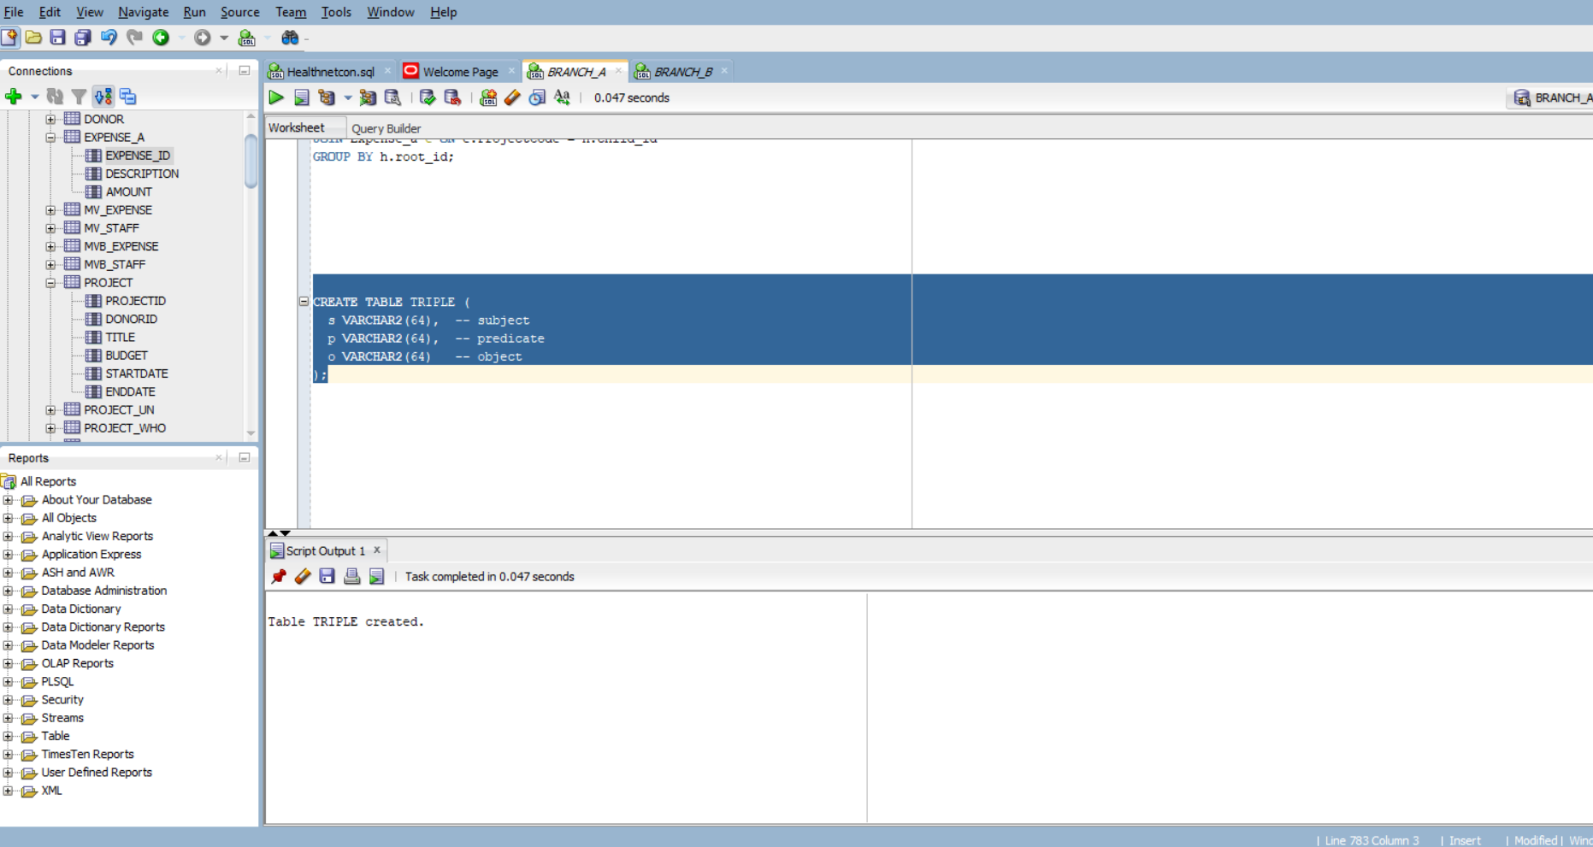

- Insert
-- Insert 10 domain facts
INSERT INTO TRIPLE VALUES ('Transport', 'isA', 'Logistics');
INSERT INTO TRIPLE VALUES ('Storage', 'isA', 'Logistics');
INSERT INTO TRIPLE VALUES ('Logistics', 'isA', 'Operations');
INSERT INTO TRIPLE VALUES ('Procurement', 'isA', 'Operations');
INSERT INTO TRIPLE VALUES ('Maintenance', 'isA', 'Operations');
INSERT INTO TRIPLE VALUES ('Operations', 'isA', 'Project');
INSERT INTO TRIPLE VALUES ('Venue Rental', 'isA', 'Transport');
INSERT INTO TRIPLE VALUES ('Fuel', 'isA', 'Transport');
INSERT INTO TRIPLE VALUES ('Warehouse Rent', 'isA', 'Storage');
INSERT INTO TRIPLE VALUES ('Tools', 'isA', 'Maintenance');
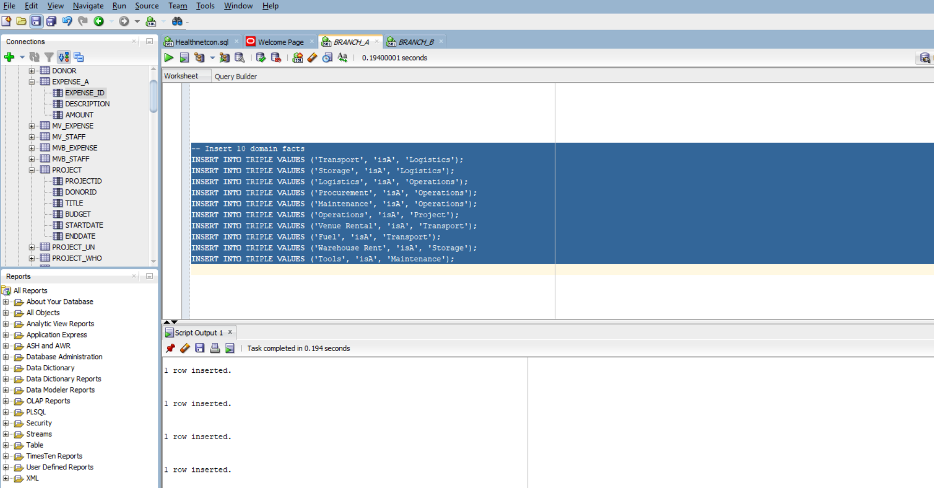

- Recursive Inference Query for Transitive isA*

WITH isA_chain (s, root, depth) AS (
-- Anchor: direct isA relationships
SELECT s, o AS root, 1 AS depth
FROM TRIPLE
WHERE p = 'isA'

UNION ALL

-- Recursive step: follow transitive isA links
SELECT t.s, c.root, c.depth + 1
FROM TRIPLE t
JOIN isA_chain c ON t.o = c.s
WHERE t.p = 'isA'
)
SELECT s AS child, root AS inferred_type, depth
FROM isA_chain
WHERE depth <= 5
FETCH FIRST 10 ROWS ONLY;

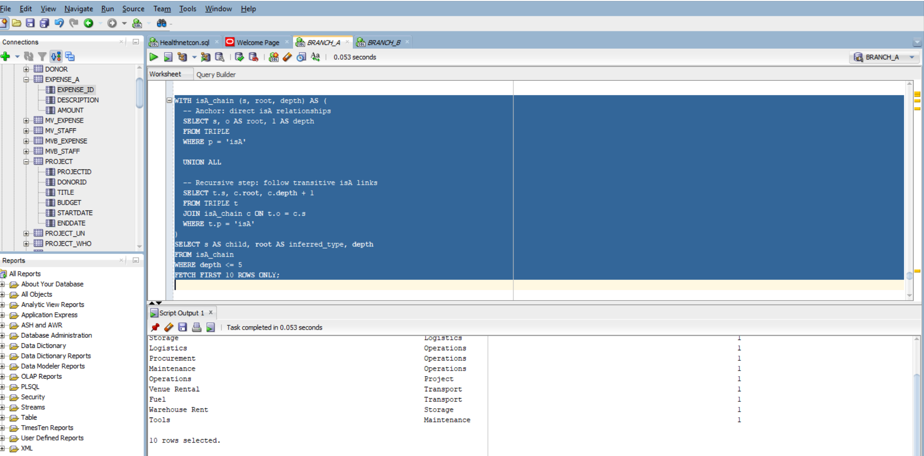
- No need to delete a row as long as total committed rows across the project (including TRIPLE) remain ≤10

B10 :Business Limit Alert (Function + Trigger) (row-budget safe)
- Create BUSINESS_LIMITS and seed exactly one active rule.

CREATE TABLE BUSINESS_LIMITS (
rule_key VARCHAR2(64),
threshold NUMBER,
active CHAR(1) CHECK (active IN ('Y', 'N'))
);

-- Seed one active rule: total expense for 'P001' must not exceed 5000
INSERT INTO BUSINESS_LIMITS (rule_key, threshold, active)
VALUES ('P001', 4000, 'Y');
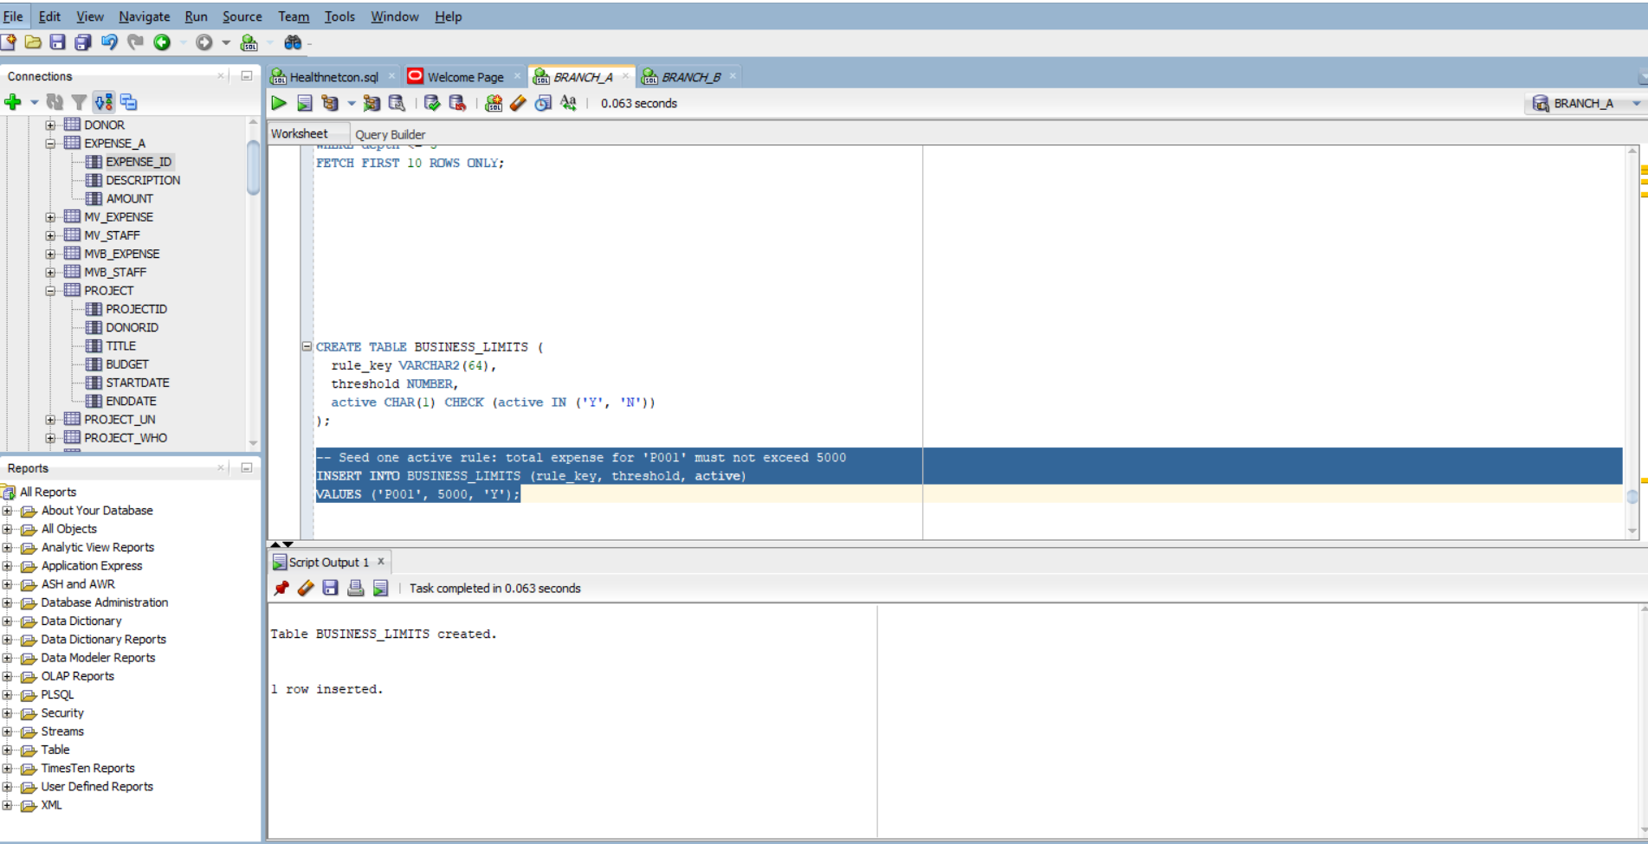

- Function that reads BUSINESS_LIMITS and inspects current data in Expense or Project to decide a violation:

CREATE OR REPLACE FUNCTION fn_should_alert(p_projectcode VARCHAR2, p_new_amount NUMBER)
RETURN NUMBER
IS
v_threshold NUMBER := 0;
v_total NUMBER := 0;
BEGIN
BEGIN
SELECT threshold INTO v_threshold
FROM BUSINESS_LIMITS
WHERE rule_key = 'MAX_PROJECT_EXPENSE' AND active = 'Y';
EXCEPTION
WHEN NO_DATA_FOUND THEN
RETURN 0; -- No rule found, allow insert/update
END;

SELECT NVL(SUM(amount), 0) INTO v_total
FROM expense_a
WHERE projectcode = p_projectcode;

IF v_total + p_new_amount > v_threshold THEN
RETURN 1;
ELSE
RETURN 0;
END IF;
END;
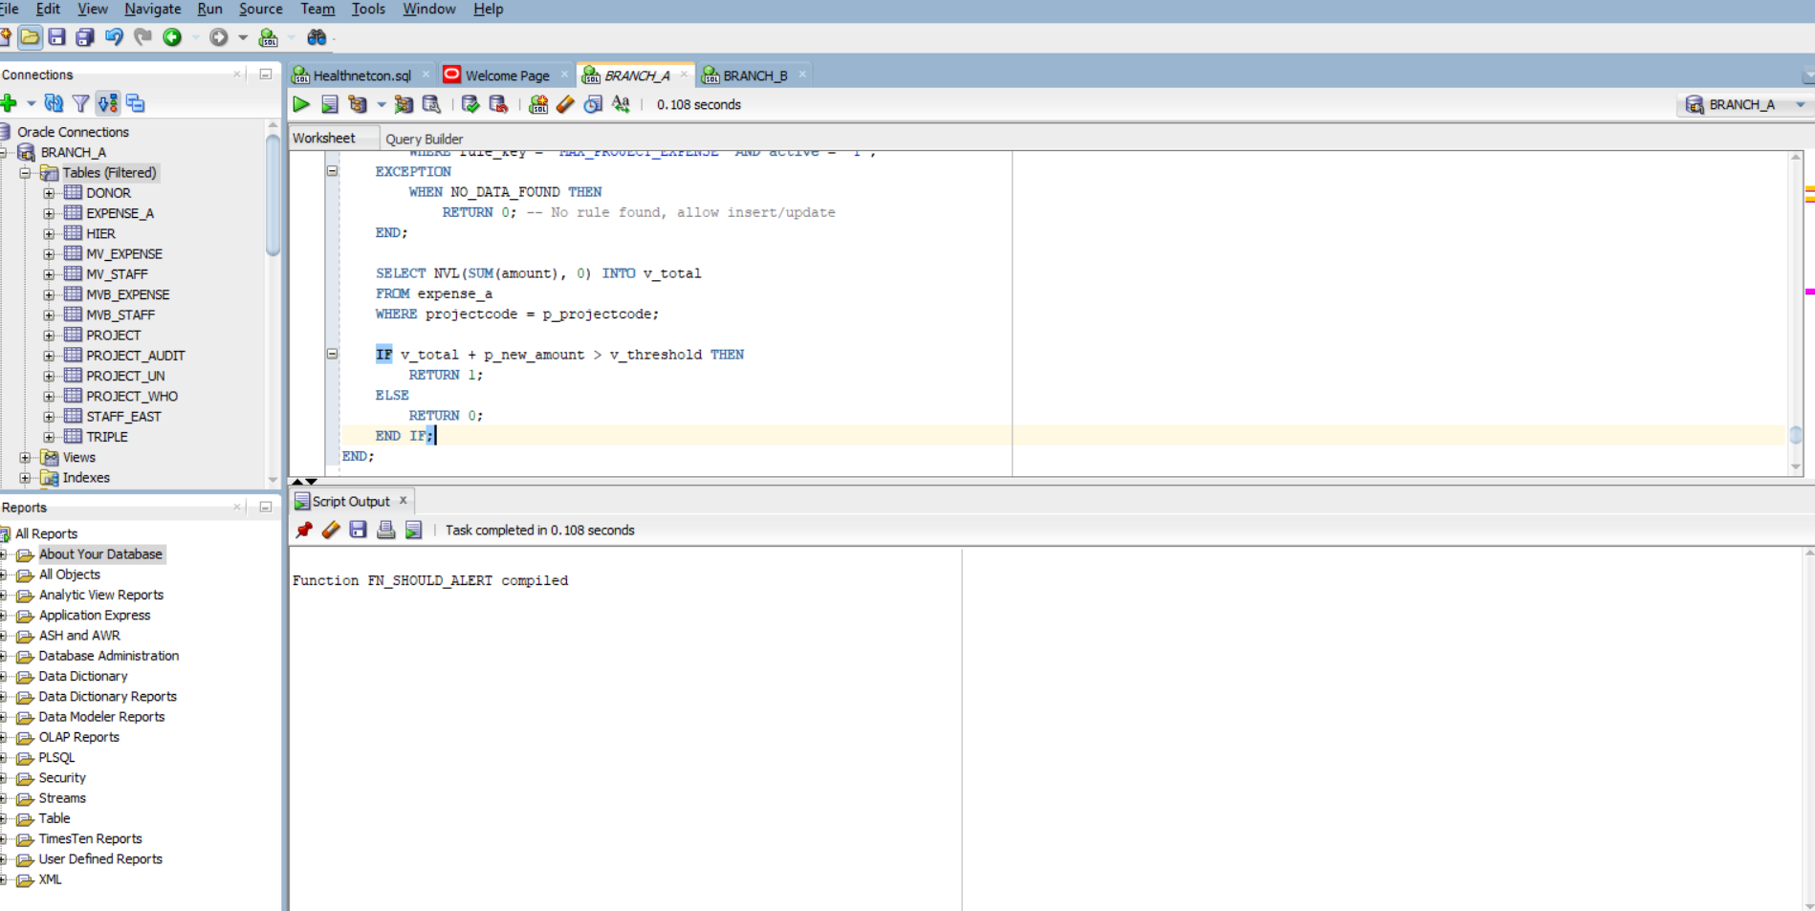

- Create a BEFORE INSERT OR UPDATE trigger on Expense
CREATE OR REPLACE TRIGGER trg_expense_alert
FOR INSERT OR UPDATE ON expense_a
COMPOUND TRIGGER

-- Declare a collection to hold project codes being modified
TYPE projectcode_tab IS TABLE OF VARCHAR2(64) INDEX BY PLS_INTEGER;
projectcodes projectcode_tab;
idx INTEGER := 0;

-- BEFORE EACH ROW: collect project codes
BEFORE EACH ROW IS
BEGIN
idx := idx + 1;
projectcodes(idx) := :NEW.projectcode;
END BEFORE EACH ROW;

-- AFTER STATEMENT: validate thresholds
AFTER STATEMENT IS
v_total NUMBER;
v_threshold NUMBER;
BEGIN
-- Get threshold
SELECT threshold INTO v_threshold
FROM BUSINESS_LIMITS
WHERE rule_key = 'MAX_PROJECT_EXPENSE' AND active = 'Y';

-- Check each projectcode once
FOR i IN 1 .. projectcodes.COUNT LOOP
SELECT NVL(SUM(amount), 0) INTO v_total
FROM expense_a
WHERE projectcode = projectcodes(i);

IF v_total > v_threshold THEN
RAISE_APPLICATION_ERROR(-20001,
'Expense threshold exceeded for project: ' || projectcodes(i));
END IF;
END LOOP;
END AFTER STATEMENT;

END trg_expense_alert;
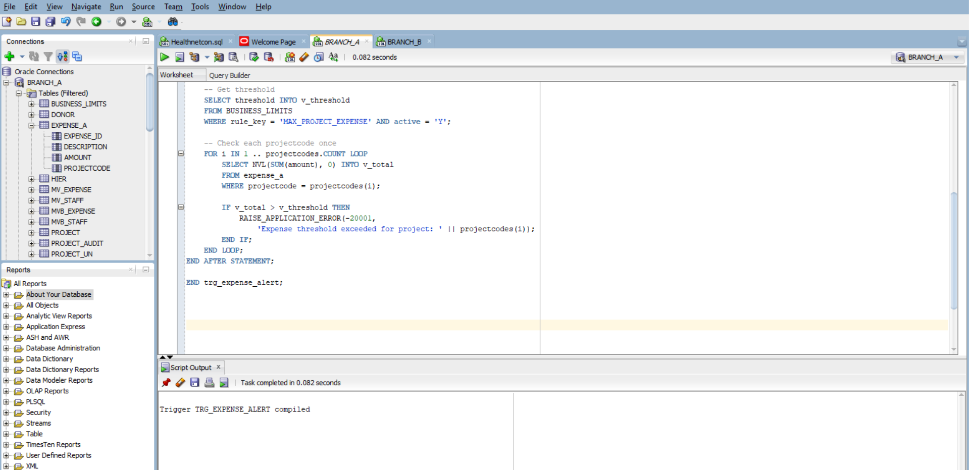
- Demonstrating 2 failing and 2 passing DML cases
2 Passing DML:

INSERT INTO expense_a VALUES (305, 'Social Media Ads', 1000, 'P005');

INSERT INTO expense_a VALUES (306, 'Legal Review', 2500, 'P004');

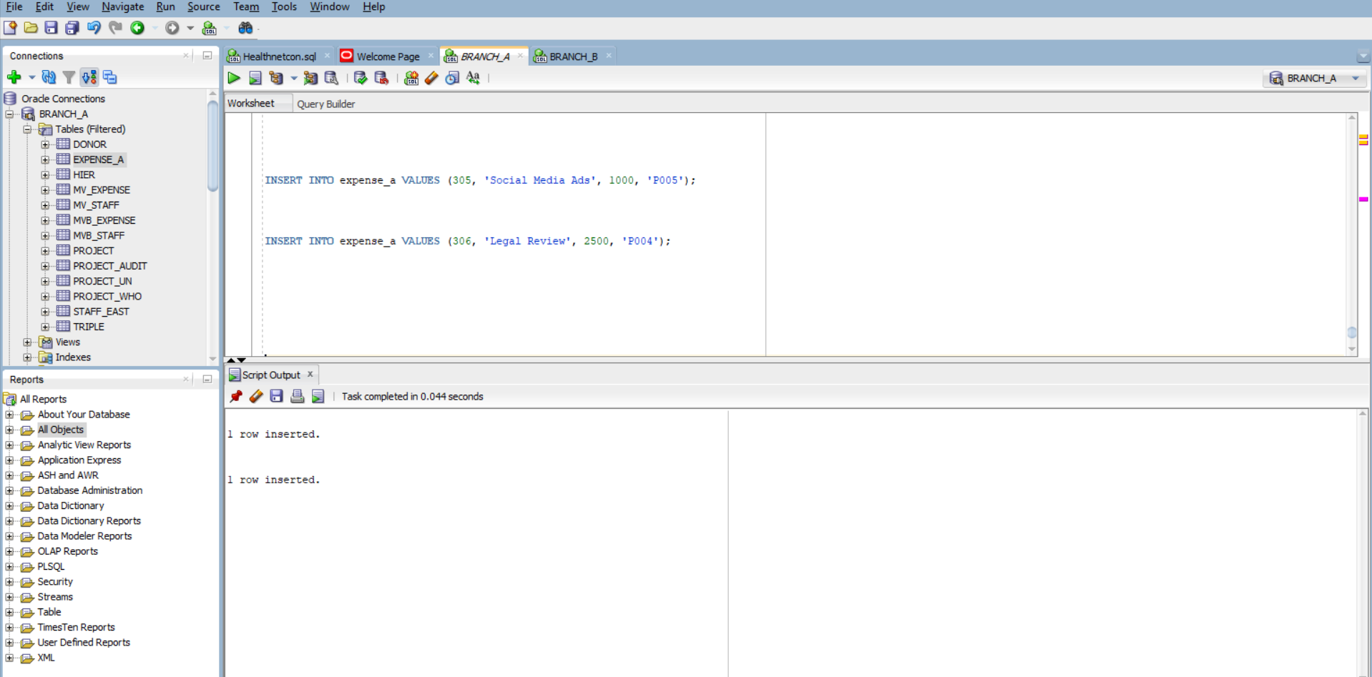

2 Failing DML:
BEGIN
INSERT INTO expense_a VALUES (309, 'Threshold Breach Test', 300, 'P001');
EXCEPTION
WHEN OTHERS THEN
DBMS_OUTPUT.PUT_LINE('FAILED: ' || SQLERRM);
ROLLBACK;
END;

BEGIN
INSERT INTO expense_a VALUES (310, 'Executive Travel Package', 3500, 'P003');
EXCEPTION
WHEN OTHERS THEN
DBMS_OUTPUT.PUT_LINE('FAILED: ' || SQLERRM);
ROLLBACK;
END;
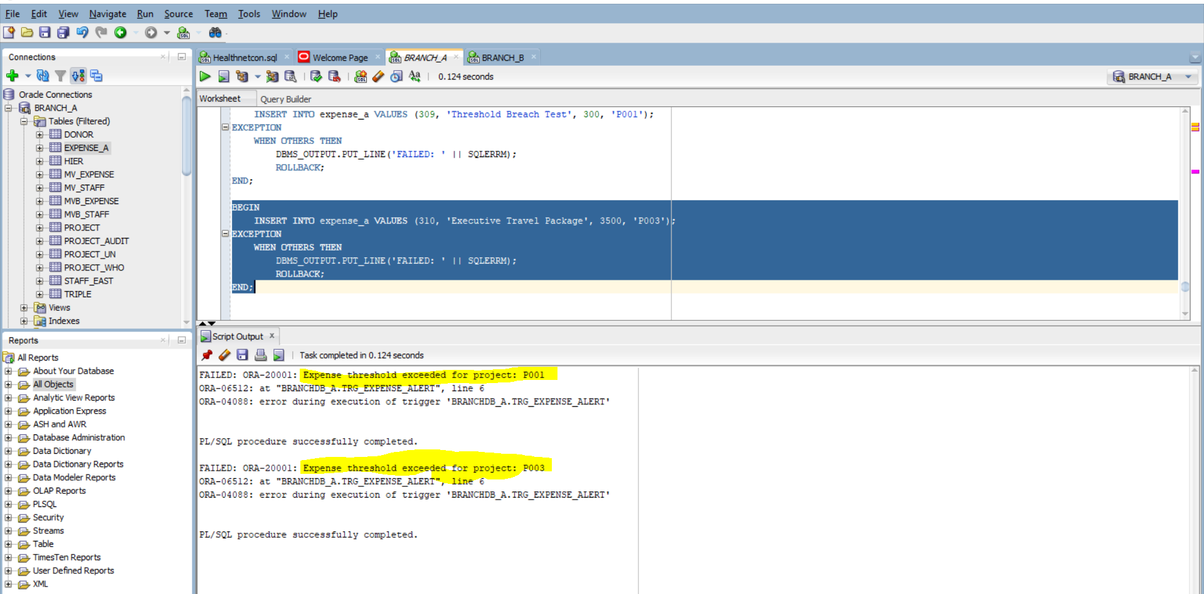

Counting Rows:
SELECT COUNT(*) FROM expense_a;
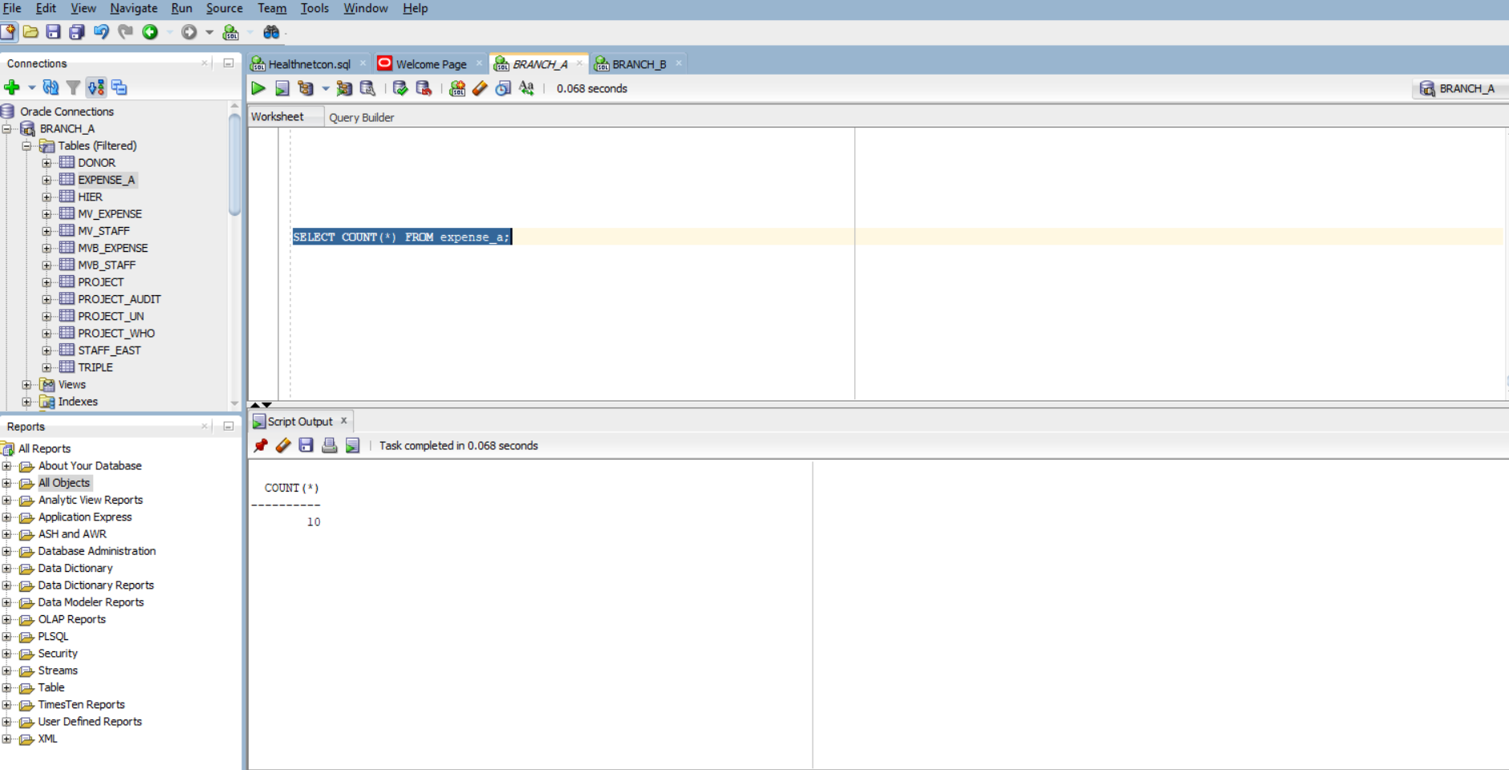

Resulting committed data:
SELECT * FROM expense_a;

